Intent-Aware Logic-Constrained Neuro-Symbolic Decision Support System with Trust Calibration for SME Multi-Channel Marketing

By

Ng Jing Yong



FACULTY OF COMPUTING AND
INFORMATION TECHNOLOGY

TUNKU ABDUL RAHMAN UNIVERSITY OF MANAGEMENT AND TECHNOLOGY
KUALA LUMPUR

ACADEMIC YEAR
2025/26

Intent-Aware Logic-Constrained Neuro-Symbolic Decision Support System with Trust Calibration for SME Multi-Channel Marketing

By

Ng Jing Yong

Supervisor: Mr. Low Choon Keat

A project report submitted to the
Faculty of Computing and Information Technology
in partial fulfillment of the requirement for the
Bachelor of Software Engineering (Honours)

Department of Software Engineering and Technology
Faculty of Computing and Information Technology
Tunku Abdul Rahman University of Management and Technology
Kuala Lumpur

Copyright by Tunku Abdul Rahman University of Management and Technology.
All rights reserved. No part of this project documentation may be reproduced, stored in retrieval system, or transmitted in any form or by any means without prior permission of Tunku Abdul Rahman University of Management and Technology.

Declaration
The project submitted herewith is a result of my own efforts in totality and in every aspect of the project works. All information that has been obtained from other sources had been fully acknowledged. I understand that any plagiarism, cheating or collusion or any sorts constitutes a breach of TAR University rules and regulations and would be subjected to disciplinary actions.

________NJY__________________
Ng Jing Yong
Bachelor of Software Engineering (Honours)
ID: 25WMR10019

Abstract
This is a one-page summary of the project (without any subheading) of usually not more than 300 words. It is often used to help the reader to quickly ascertain the documentation’s purpose. Like all summaries, abstract covers the main points of a piece of writing that includes the field of study, problem statement, methodology adopted, research process, conclusion and planning of the project work, etc. It helps readers understand the project by acting as a pre-reading outline of key points.
The contents that you may include in an abstract are as follows:
Purpose: Describes the main purpose of carrying the project, i.e. to justify the existence of the project by stating the existing problem to be solved. Explain why it is necessary to solve it and how the project contributes to the solution.
Scope: This covers areas or size of the project in terms of function and features of the system, modules or sub-modules involved, and functional areas covered in an organization.
Methodology: To describe the methodology, tools, techniques and models that are used throughout the project.
Testing criteria used: To describe the various assessment areas this project has undergone.
Results and Conclusion: To brief the outcome, strengths and weakness of the system or the entire project.
Note: Your abstract SHOULD NOT have bullet points or headings according to the contents listed above. Refer to abstracts of research papers for examples of abstracts.

Acknowledgement
First and foremost, I would like to express my deepest gratitude to my project supervisor, Mr. Low Choon Keat, for his continuous guidance, valuable advice, constructive feedback, and unwavering support throughout the duration of this Final Year Project. His insights and encouragement have greatly contributed to the successful completion of this project.
I would also like to sincerely thank the lecturers and faculty members of the Faculty of Computing and Information Technology, Tunku Abdul Rahman University of Management and Technology, for providing the necessary academic foundation, resources, and learning environment that enabled me to carry out this project effectively.
I would also like to express my sincere gratitude to my moderator, Dr. Chin Wan Yoke and Ms. Joan Hau, for her valuable guidance, constructive feedback, and continuous support throughout this research. Her insightful advice and recommendations have greatly contributed to the improvement and refinement of this study.
I am also grateful to the SME practitioners and individuals who participated, directly or indirectly, in providing feedback and insights for the evaluation of this project. Their contributions have helped strengthen the practical relevance of the proposed system.
Last but not least, I would like to thank my family for their endless love, patience, moral support, and encouragement throughout my academic journey. Their continuous motivation has been a great source of strength and inspiration.
This project would not have been possible without the support and contributions of all the individuals mentioned above. Thank you.

Table of Contents
Declaration ii
Abstract iii
Acknowledgement iv
Table of Contents v
1 Introduction 2
1.1 Project Objective(s) 4
1.1.1 General Objective 4
1.1.2 Specific Objectives 4
1.2 Research Questions 5
1.3 Project Background 5
1.3.1 SME Marketing Decision Support 6
1.3.2 Evolution of Artificial Intelligence in Marketing 6
1.3.3 Emergence of Neuro-Symbolic Artificial Intelligence 7
1.3.4 Trust Calibration and Human-AI Collaboration 8
1.3.5 Motivation of the Proposed Project 8
1.4 Problem Statement 8
1.4.1 Attribution-to-Action Gap 9
1.4.2 Lack of Strategic Intent Awareness 10
1.4.3 Limited Integration of Business Constraints 10
1.4.4 Lack of Trust Calibration and Transparency 10
1.4.5 Limited Auditability and Managerial Accountability 11
1.4.6 Proposed Solution 11
1.5 Project Contributions 12
1.5.1 Technical Contributions 12
1.5.2 Methodological Contributions 13
1.5.3 Practical Contributions 14
1.5.4 Summary of Project Contributions 15
1.6 Project Scope 15
1.6.1 Included Scope 15
1.6.2 Excluded Scope 18
1.6.3 Project Boundary Summary 19
1.7 Project Plan and Development Approach 20
1.7.1 Development Methodology 21
1.7.2 Development Phases 23
1.8 Chapter Summary and Evaluation 24
2 Literature Review 27
2.1 Traditional Marketing Analytics and the Attribution-to-Action Gap 27
2.1.1 Evolution of Marketing Analytics 27
2.1.2 Limitations of Predictive and Attribution Models 30
2.1.3 Implications for SMEs and the Attribution-to-Action Gap 31
2.2 Neuro-Symbolic Artificial Intelligence for Decision Support 32
2.2.1 Overview of Neuro-Symbolic Artificial Intelligence 33
2.2.2 Taxonomy of Neuro-Symbolic Architectures 34
2.2.3 Performance and Capabilities 36
2.2.4 Limitations and Challenges 37
2.3 Trust Calibration and Human-AI Decision-Making 38
2.3.1 The Problem of Overtrust and Undertrust 38
2.3.2 Limitations of Explainability Alone 39
2.3.3 Trust Calibration Mechanisms 40
2.3.4 Structured Explanations for Decision Support 42
2.4 Research Gaps and Justification of Proposed System 44
2.4.1 Synthesis of Existing Literature 44
2.4.2 Identified Research Gaps 44
2.4.3 Justification of the Proposed System 46
2.4.4 Research Contribution 48
2.5 Chapter Summary and Evaluation 50
3 Methodology and Requirements Analysis 53
3.1 Introduction 53
3.2 Research Methodology Overview 53
3.2.1 Research Approach 53
3.2.2 Experimental Design Framework 54
3.3 System Development Methodology 55
3.3.1 Development Strategy 55
3.3.2 System Pipeline Overview 56
3.4 Data Requirements and Preparation 57
3.4.1 Dataset Requirements 57
3.4.2 Data Sources 58
3.4.3 Decision Case Construction 58
3.4.4 Data Splitting Strategy 59
3.5 System Components 60
3.5.1 Predictive-Attribution Backbone 60
3.5.2 Candidate Action Generation 60
3.5.3 Weighted Soft-Rule Reasoning 61
3.5.4 Intent-Aware Decision Module 61
3.5.5 Trust Calibration Module 62
3.5.6 Structured Explanation Generation 62
3.6 Evaluation Methodology 63
3.6.1 Baseline Systems 64
3.6.2 Ablation Study Design 64
3.6.3 Evaluation Metrics 65
3.6.4 Human Evaluation Procedure 67
3.6.5 Statistical Analysis 67
3.7 Requirement Gathering Techniques 67
3.7.1 Overview 67
3.7.2 Literature Analysis 68
3.7.3 Problem Analysis 68
3.7.4 Framework Synthesis 68
3.8 System Requirements Analysis 69
3.8.1 Functional Requirements 69
3.8.2 Non-Functional Requirements 70
3.8.3 Use Case Analysis 70
3.8.4 System Constraints 70
3.9 Chapter Summary and Evaluation 71
4 System Design 74
4.1 Overall System Architecture 74
4.2 System Workflow Design 76
4.2.1 High-Level Workflow 76
4.3 UML Design 78
4.3.1 Class Diagram 78
4.3.2 Use Case Diagram 78
4.3.3 Activity Diagram 79
4.3.4 Sequence Diagram 80
4.4 Database Design 81
4.4.1 ER Diagram 81
4.4.2 Database Schema 82
4.5 Algorithm Design 85
4.5.1 Algorithm 1: Predictive Attribution 85
4.5.2 Algorithm 2: Logic-Constrained Reasoning 87
4.5.3 Algorithm 3: Trust Calibration 89
4.5.4 Algorithm 4: Explanation Generation 91
4.6 User Interface Design 92
4.7 Chapter Summary and Evaluation 93
5 Implementation and Testing 95
5.5 Sub-section 1 Heading 95
5.5.1 Sub-subsection Heading 95
5.6 Sub-section 2 Heading 95
5.7 Sub-section 1 Heading 95
5.7.1 Sub-subsection Heading 95
5.8 Sub-section 1 Heading 96
5.8.1 Sub-subsection Heading 96
5.9 Chapter Summary and Evaluation 96
6 System Deployment 98
6.1 System Backup and Risk Management 98
6.2 On-site Setup 98
6.3 Training Procedure 98
6.4 Follow-up 98
6.5 Chapter Summary and Evaluation 98
7 Discussions and Conclusion 100
7.1 Summary 100
7.2 Achievements 100
7.3 Contributions 100
7.4 Limitations and Future Improvements 100
7.5 Issues and Solutions 100
References 101
Appendices 104

Chapter 1

Introduction

Introduction
The rapid growth of digital technologies has transformed the way organisations conduct marketing activities and interact with customers. Small and Medium Enterprises (SMEs) increasingly utilise multiple digital channels, including social media platforms, customer relationship management (CRM) systems, e-commerce platforms, online advertising networks, and transactional databases to improve customer engagement and business performance. These channels continuously generate large volumes of heterogeneous data that contain valuable information regarding customer behaviour, campaign effectiveness, and market trends (Wedel & Kannan, 2016). The ability to transform these data into effective managerial decisions has become an important competitive capability for modern SMEs.
Despite the increasing availability of marketing data, many SMEs continue to experience difficulties in converting analytical insights into practical business actions. Existing marketing analytics solutions primarily focus on predictive modelling and attribution analysis. Predictive models estimate future customer behaviour or campaign outcomes, while attribution models evaluate the relative contribution of different marketing channels to business objectives (Li & Kannan, 2014; Berman, 2018). Although these approaches improve the understanding of marketing performance, they generally provide descriptive or predictive information rather than actionable recommendations that directly support managerial decision-making.
This limitation creates what may be described as the attribution-to-action gap, where analytical systems successfully identify patterns and relationships but fail to recommend suitable next actions that align with organisational objectives and operational constraints. In practical SME environments, managers are often required to determine whether marketing resources should be increased, maintained, reduced, or further investigated. Such decisions must consider not only historical data but also business priorities, budget limitations, strategic objectives, and acceptable levels of risk. Conventional analytics platforms rarely incorporate these factors into a unified decision-support process.
The growing adoption of artificial intelligence (AI) has introduced new opportunities for intelligent decision support but has also created additional challenges. Many modern AI systems rely on complex machine learning models that operate as black-box mechanisms, making it difficult for users to understand how recommendations are generated (Ribeiro et al., 2016). The absence of transparent reasoning reduces user confidence and may lead to inappropriate reliance on AI-assisted recommendations. Users may either overtrust incorrect recommendations or ignore useful suggestions because the underlying decision process is not sufficiently interpretable (Green & Chen, 2019; Vasconcelos et al., 2023).
Recent studies in human-AI collaboration suggest that explainability alone is insufficient to achieve effective decision support. Users should be able to understand not only the reasoning process but also the degree of uncertainty associated with system outputs. Trust calibration aims to align human confidence with the actual reliability of AI systems, thereby reducing both overreliance and underreliance on automated recommendations (Guo et al., 2017; Schemmer et al., 2023). Decision-support systems that communicate confidence appropriately can improve the quality of managerial judgement and encourage more responsible adoption of AI technologies.
Neuro-symbolic artificial intelligence has emerged as a promising research direction that combines the pattern recognition capabilities of neural learning with the explicit reasoning capabilities of symbolic knowledge representation (Shakarian et al., 2023; Himabindu et al., 2023). Neural components are capable of learning complex relationships from large datasets, whereas symbolic components encode domain knowledge, business policies, and operational constraints in a structured and interpretable manner. This hybrid approach provides opportunities to generate recommendations that are both data-driven and logically consistent.
In the context of SME marketing, decision support requires more than prediction accuracy alone. Recommendations should reflect the strategic intent of the organisation, remain compatible with business constraints, provide understandable reasoning, and communicate confidence levels that enable appropriate managerial reliance. Existing approaches often address these requirements individually, but relatively few integrate them into a unified framework designed for resource-constrained SME environments.
To address these limitations, this project proposes an Intent-Aware Logic-Constrained Neuro-Symbolic Decision Support System with Trust Calibration for SME Multi-Channel Marketing. The proposed system integrates predictive analytics, intent-aware decision-making, weighted business constraints, calibrated confidence estimation, and structured explanation generation into a single decision-support architecture. Rather than functioning as an autonomous marketing platform, the system is designed to assist managers by providing transparent and auditable recommendations while preserving human control over final decisions.
The project introduces three predefined business intent scenarios, namely survival, retention, and growth, to ensure that recommendations remain aligned with strategic objectives. A weighted soft-rule reasoning mechanism is incorporated to enforce business constraints without excessively restricting feasible alternatives, while trust calibration mechanisms provide confidence estimates that better reflect actual recommendation reliability. Structured explanations are generated to improve transparency and facilitate managerial understanding of the decision process.
The scope of the proposed system is intentionally limited to decision support. Automated execution of marketing campaigns, enterprise-scale optimisation, and unrestricted generative content creation are excluded to maintain practical feasibility and ensure that the project remains aligned with the objectives of a software engineering research project. By focusing on recommendation quality, logical consistency, and trustworthy human-AI collaboration, the project seeks to bridge the gap between analytical outputs and practical managerial action.
The remainder of this chapter presents the project objectives, background, problem statement, scope, expected contributions, and development approach that establish the foundation for the proposed system and guide the subsequent stages of research, system design, implementation, and evaluation.
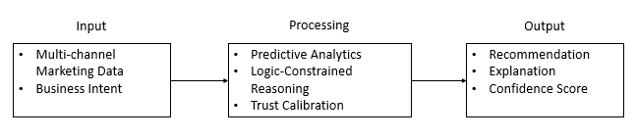Figure 1.1: High-Level Conceptual Framework of the Proposed Decision Support System

Project Objective(s)
The primary objective of this project is to develop a trustworthy AI-assisted decision support system that assists Small and Medium Enterprises (SMEs) in making transparent and actionable multi-channel marketing decisions. The proposed system seeks to bridge the gap between analytical insights and practical business actions by integrating predictive analytics, symbolic reasoning, strategic intent modelling, and trust calibration.

General Objective
To design, develop, and evaluate an intent-aware logic-constrained neuro-symbolic decision support system with trust calibration that generates transparent and actionable recommendations for SME multi-channel marketing.
The proposed system integrates machine learning predictions, symbolic business constraints, strategic intent modelling, and trust calibration mechanisms to improve recommendation quality while preserving human oversight and decision-making authority.

Specific Objectives
RO1. To develop an anonymised and frozen benchmark dataset consisting of multi-channel marketing decision cases accompanied by predefined business intent scenarios.
RO2. To implement a predictive-attribution backbone integrated with a weighted soft-rule recommendation layer for generating intent-consistent marketing actions.
RO3. To develop a trust calibration and structured explanation module that communicates recommendation confidence and supporting evidence.
RO4. To evaluate the proposed system in terms of recommendation actionability, logical consistency, recommendation relevance, decision certainty, and system latency against partial baseline approaches.
The objectives defined in this section establish the foundation for the subsequent chapters. Chapter 2 reviews the theoretical and technical literature related to neuro-symbolic AI, explainable AI, trust calibration, and marketing decision support. Chapter 3 then translates these objectives into a detailed system architecture and implementation methodology, while the later chapters evaluate whether the proposed objectives have been successfully achieved.

Research Questions
RQ1. Can an integrated predictive-attribution backbone with weighted soft-rule reasoning generate more effective recommendations than purely predictive or attribution-based approaches?
RQ2. Do confidence calibration and structured explanation mechanisms improve appropriate reliance on AI-assisted recommendations?
RQ3. Does business intent conditioning improve the contextual relevance of generated recommendations?
RQ4. Is the proposed system practically feasible in terms of auditability, interaction latency, and implementation complexity?

Project Background
The increasing digitalisation of business operations has significantly changed the marketing landscape for Small and Medium Enterprises (SMEs). Traditional marketing approaches that relied primarily on intuition and limited customer information have gradually evolved into data-driven practices supported by social media platforms, e-commerce systems, customer relationship management (CRM) applications, and digital advertising networks. These technologies enable organisations to collect and analyse large volumes of customer and campaign data, creating opportunities for more informed strategic decision-making (Wedel & Kannan, 2016).
Despite these advancements, many SMEs face challenges in fully utilising marketing data due to limited financial resources, shortage of technical expertise, and the increasing complexity of multi-channel customer interactions. Unlike large enterprises that can invest in specialised analytics teams and enterprise-scale decision support platforms, SMEs often rely on simplified dashboards or isolated analytical tools that provide descriptive statistics without offering actionable guidance. Consequently, marketing managers frequently make decisions based on personal experience or incomplete information, potentially reducing campaign effectiveness and increasing business risks.

SME Marketing Decision Support
Decision support systems (DSS) have long been used to assist organisations in solving semi-structured and unstructured business problems by integrating data processing, analytical models, and human judgement (Power, 2002). In the context of marketing, decision support systems help managers evaluate campaign performance, allocate marketing budgets, identify customer segments, and optimise resource utilisation.
However, many existing marketing decision support systems primarily focus on reporting historical performance or predicting future outcomes. While these capabilities are useful, they do not necessarily provide direct recommendations regarding the most appropriate business actions. Marketing managers still need to interpret analytical outputs and manually determine suitable strategies, creating a gap between prediction and practical decision-making.
This limitation becomes increasingly significant in multi-channel marketing environments, where decisions involve balancing multiple objectives such as customer acquisition, customer retention, revenue growth, operational cost, and resource constraints. A decision support system capable of incorporating these factors into a unified recommendation process may improve both efficiency and decision quality.

Evolution of Artificial Intelligence in Marketing
Artificial intelligence has become an important technology for enhancing marketing analytics and business decision support. Machine learning algorithms are widely applied to customer segmentation, demand forecasting, recommendation systems, churn prediction, and marketing attribution modelling due to their ability to identify complex relationships within large datasets (Berman, 2018).
Although machine learning models often achieve high predictive accuracy, many advanced algorithms function as black-box systems that provide limited insight into their internal reasoning processes. The lack of transparency can reduce user trust and make it difficult for decision makers to understand why a particular recommendation has been generated (Ribeiro et al., 2016).
Explainable Artificial Intelligence (XAI) has emerged to address this challenge by providing methods that improve the interpretability of AI models. Techniques such as feature attribution and local explanation methods help users understand the factors influencing predictions. Nevertheless, explainability alone does not guarantee that recommendations comply with business policies or strategic objectives. AI systems may still generate outputs that are technically accurate but operationally impractical or inconsistent with organisational priorities.
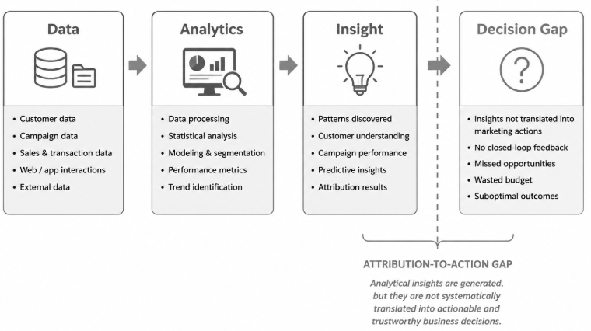Figure 1.2: Attribution-to-Action Gap in Existing Marketing Decision Support Systems

Emergence of Neuro-Symbolic Artificial Intelligence
Recent developments in neuro-symbolic artificial intelligence seek to combine the strengths of data-driven learning with explicit symbolic reasoning. Neural learning components are effective in extracting patterns from complex data, whereas symbolic reasoning enables systems to represent domain knowledge, business policies, and operational constraints in a transparent and interpretable manner (Dellermann et al., 2019).
For business decision support applications, symbolic reasoning can provide additional safeguards by ensuring that recommendations remain logically consistent with predefined organisational rules. Instead of relying exclusively on statistical relationships, neuro-symbolic approaches integrate analytical evidence with structured knowledge, thereby improving transparency and supporting more explainable decision-making.
In SME marketing environments, such an approach may help bridge the gap between predictive analytics and actionable recommendations by combining historical data analysis with business-oriented reasoning processes.

Trust Calibration and Human-AI Collaboration
The successful adoption of AI-assisted decision support depends not only on system performance but also on the quality of human-AI collaboration. Research has shown that users may either overtrust AI systems by accepting incorrect recommendations without sufficient scrutiny or undertrust them by disregarding useful advice (Lee & See, 2004).
Trust calibration aims to align user confidence with the actual reliability of AI outputs. Rather than encouraging unconditional acceptance of AI recommendations, calibrated trust helps users understand when the system is likely to be reliable and when additional human judgement may be required (Guo et al., 2017; Schemmer et al., 2023).
In marketing decision support, appropriate trust calibration is particularly important because business decisions often involve financial risks, uncertain market conditions, and incomplete information. Systems that communicate confidence levels and provide understandable reasoning can improve managerial decision-making and encourage more responsible use of AI technologies.

Motivation of the Proposed Project
The literature indicates that existing marketing analytics solutions often address individual aspects of decision support, such as prediction accuracy, explainability, or business intelligence reporting. However, relatively few systems integrate predictive analytics, strategic intent modelling, symbolic business constraints, and trust calibration into a unified framework specifically designed for SME multi-channel marketing.
Motivated by these research and practical gaps, this project proposes an Intent-Aware Logic-Constrained Neuro-Symbolic Decision Support System with Trust Calibration. The proposed system seeks to transform analytical outputs into transparent, actionable, and trustworthy recommendations while maintaining human oversight and preserving managerial decision authority.
The project therefore contributes not only to the development of an intelligent software system but also to the broader objective of supporting responsible and trustworthy AI adoption in SME marketing environments.

Problem Statement
The rapid expansion of digital marketing technologies has enabled Small and Medium Enterprises (SMEs) to collect substantial amounts of customer and campaign data from multiple channels, including social media platforms, e-commerce systems, customer relationship management (CRM) applications, and online advertising networks. Although these data sources provide valuable business insights, many SMEs continue to face challenges in transforming analytical outputs into practical managerial actions. Existing marketing analytics solutions often emphasise prediction and performance measurement while providing limited support for transparent, trustworthy, and context-aware decision-making.
The literature and industrial practice reveal several important limitations that motivate the development of the proposed system.
Table 1.1: Summary of Identified Problems
Problem ID | Description | Impact on SMEs
P1 | Attribution-to-action gap | Marketing insights are not systematically translated into actionable decisions.
P2 | Lack of Strategic Intent Awareness | Recommendations may not align with organisational goals such as survival, retention, or growth.
P3 | Limited Integration of Business Constraints | Suggested actions may violate budget, policy, or operational limitations
P4 | Lack of Trust Calibration and Transparency | Users may over trust unreliable recommendations or ignore useful advice.
P5 | Limited Auditability and Managerial Accountability | Decision processes become difficult to understand, verify, and justify.

Attribution-to-Action Gap
Marketing analytics platforms commonly provide descriptive reports, predictive forecasts, and attribution analyses that estimate the contribution of various marketing channels toward business outcomes (Li & Kannan, 2014; Berman, 2018). While these approaches help organisations understand historical performance, they rarely answer a critical managerial question:
What action should the business take next?
Marketing managers must frequently determine whether to increase advertising expenditure, maintain existing strategies, reduce investment, or conduct further investigation. Such decisions require balancing analytical evidence with business objectives and operational constraints. However, most existing systems leave the final interpretation entirely to users, creating an attribution-to-action gap between data analysis and practical decision support.
For SMEs with limited resources and specialised expertise, this gap may lead to delayed decisions, inconsistent strategies, and inefficient allocation of marketing resources.

Lack of Strategic Intent Awareness
Business decisions are often influenced by organisational priorities that may change according to market conditions and organisational maturity. For example, newly established businesses may prioritise survival and cost control, while more established organisations may focus on customer retention or business expansion.
Most existing AI-driven marketing systems optimise recommendations according to predefined mathematical objectives without explicitly considering different strategic intents. Consequently, the same analytical evidence may produce recommendations that are technically valid but inconsistent with the actual goals of the organisation.
The absence of strategic intent modelling reduces the practical applicability of many marketing recommendation systems and limits their ability to support diverse SME operational requirements.

Limited Integration of Business Constraints
Machine learning algorithms primarily learn statistical relationships from historical data. Although these models may achieve high predictive performance, they do not inherently guarantee that generated recommendations satisfy organisational policies, operational limitations, or business rules.
In practical environments, marketing decisions are constrained by factors such as budget availability, resource capacity, campaign policies, and risk tolerance. Recommendations that ignore these constraints may be difficult or impossible to implement.
Traditional expert systems provide explicit rule enforcement but often lack the adaptability and learning capability of modern AI techniques. Conversely, purely data-driven models provide flexibility but may generate recommendations that conflict with business requirements. The limited integration of predictive analytics with explicit business constraints therefore remains an important challenge in marketing decision support.

Lack of Trust Calibration and Transparency
Artificial intelligence systems are increasingly applied to support business decisions, yet many advanced machine learning models operate as black-box mechanisms that provide limited explanation regarding their outputs (Ribeiro et al., 2016). The inability to understand system reasoning may reduce user confidence and hinder organisational adoption of AI technologies.
Research in human-AI collaboration further indicates that users may develop inappropriate reliance behaviours when interacting with intelligent systems. Overtrust may cause users to accept incorrect recommendations without sufficient evaluation, while undertrust may result in the rejection of beneficial advice (Lee & See, 2004).
Although explainable AI techniques can improve transparency, explanations alone do not necessarily communicate the reliability or uncertainty associated with system outputs. Many existing decision support systems therefore provide insufficient support for calibrated trust, increasing the risk of poor human-AI collaboration.

Limited Auditability and Managerial Accountability
Business decisions, particularly those involving financial investment and marketing expenditure, require adequate documentation and justification. Managers should be able to understand the factors that influenced recommendations and review the reasoning process when evaluating organisational outcomes.
Many AI systems generate predictions without maintaining structured records of decision logic, applied constraints, and confidence estimates. The lack of auditable decision processes reduces transparency and may create difficulties for organisational governance and future decision analysis.
For SMEs that increasingly adopt AI-assisted technologies, maintaining accountability and traceability is important for responsible business management and sustainable AI deployment.

Proposed Solution
To address these limitations, this project proposes an Intent-Aware Logic-Constrained Neuro-Symbolic Decision Support System with Trust Calibration for SME Multi-Channel Marketing.
The proposed system seeks to:
- integrate predictive analytics with symbolic business constraints;
- incorporate predefined strategic business intents into recommendation generation;
- provide weighted soft-rule reasoning to improve logical consistency;
- estimate recommendation confidence through trust calibration mechanisms;
- generate structured explanations that improve transparency and auditability; and
- support managerial decision-making while preserving human control over final actions.
Rather than replacing human decision makers, the proposed system functions as an intelligent decision support tool that combines analytical evidence with business knowledge to generate recommendations that are actionable, understandable, and trustworthy.
By addressing the attribution-to-action gap, strategic intent alignment, business constraint enforcement, trust calibration, and auditability, this project aims to contribute to the development of more effective AI-assisted decision support systems for SME multi-channel marketing.
To maintain practical feasibility and experimental rigour, the project adopts a bounded research design. The benchmark dataset, business intent taxonomy, recommendation action space, and evaluation procedures are defined prior to system development and remain unchanged throughout experimentation. This bounded approach reduces arbitrary model adjustments, improves auditability, and supports reproducible evaluation of the proposed decision support framework.

Project Contributions
The increasing adoption of artificial intelligence (AI) in business environments has created opportunities to improve marketing decision-making through predictive analytics and automated recommendations. However, many existing solutions emphasise prediction accuracy while providing limited support for strategic alignment, logical consistency, and appropriate human trust. The proposed project seeks to address these limitations by integrating multiple complementary components into a unified decision support framework for SME multi-channel marketing.
The expected contributions of this project can be categorised into technical, methodological, and practical contributions.

Technical Contributions
The primary technical contribution of this project is the design and development of an Intent-Aware Logic-Constrained Neuro-Symbolic Decision Support System with Trust Calibration for SME multi-channel marketing.
Unlike conventional marketing analytics systems that primarily provide predictive outputs, the proposed system integrates several complementary capabilities within a single architecture:
- predictive analytics for marketing performance estimation;
- intent-aware recommendation generation based on organisational priorities;
- weighted soft-rule reasoning for business constraint enforcement;
- trust calibration for communicating recommendation confidence; and
- structured explanation generation for improving transparency and auditability.
The integration of these components allows the system to generate recommendations that are not only data-driven but also aligned with business objectives and operational requirements.
A second technical contribution is the incorporation of strategic intent modelling into the recommendation process. The system introduces predefined business intent categories, namely survival, retention, and growth, to reflect different organisational priorities. This mechanism enables the recommendation engine to adapt its decision strategy according to the selected business objective instead of applying a single optimisation policy to all situations.
A third technical contribution is the implementation of a weighted soft-rule reasoning mechanism that incorporates business constraints without excessively limiting system flexibility. Rather than relying solely on statistical predictions or rigid rule-based decision making, the proposed approach combines analytical evidence with symbolic knowledge to improve recommendation consistency.
Another contribution of the project is the establishment a frozen benchmark dataset with predefined business intent scenarios to ensure experimental reproducibility and evaluation consistency.
The system incorporates a predictive-attribution backbone that provides analytical evidence for subsequent decision-making rather than functioning as a standalone recommendation engine.
In addition, the project adopts a structured explanation format consisting of four components:
- Driver
- Implication
- Action
- Caveat
This explanation structure is intended to improve recommendation transparency and facilitate managerial auditing.
Finally, the trust calibration module applies probability calibration techniques to estimate recommendation confidence and evaluates system behaviour using calibration-related metrics such as Expected Calibration Error (ECE), trust alignment gap, and overthrust rate.

Methodological Contributions
From a research perspective, this project contributes a framework for integrating predictive modelling, symbolic reasoning, and trust calibration within a unified decision support architecture.
Many existing studies investigate these topics independently. Predictive analytics research commonly focuses on improving model accuracy, explainable AI research emphasises interpretability, and trust research examines human reliance on intelligent systems. The proposed framework combines these research directions into a single software engineering solution that supports practical managerial decision-making.
The project further contributes by adopting a multidimensional evaluation strategy. In addition to conventional predictive performance measures, the system will be evaluated using metrics related to recommendation consistency, calibration quality, transparency, and human-centred usability. This broader evaluation perspective provides a more comprehensive assessment of decision support effectiveness than approaches that rely exclusively on prediction accuracy.
The project is also informed by findings from the systematic literature review conducted by the author, which synthesised current evidence regarding neuro-symbolic AI, explainable AI, trust calibration, and decision support for SME marketing environments. The proposed architecture is therefore grounded in existing research while addressing identified gaps in the literature.

Practical Contributions
From an industrial perspective, the proposed system aims to support SMEs that often operate under resource constraints and may lack access to advanced marketing analytics expertise.
The system is intended to assist managers by providing transparent recommendations that combine analytical evidence with business knowledge. Rather than replacing human judgement, the system functions as an advisory tool that helps decision makers evaluate alternative actions while retaining full managerial control over final decisions.
The structured explanation mechanism is expected to improve user understanding of recommendation outcomes, while trust calibration provides additional information regarding recommendation reliability. These features may encourage more appropriate use of AI-assisted technologies and reduce the risks associated with overreliance or underreliance on automated systems.
Furthermore, the project promotes the principles of responsible AI by emphasising transparency, auditability, and human oversight. These characteristics are increasingly recognised as important requirements for the sustainable adoption of AI technologies in business environments.

Summary of Project Contributions
The principal contributions of this project are summarised as follows:
- Development of an intent-aware neuro-symbolic decision support architecture for SME multi-channel marketing.
- Integration of predictive analytics, weighted business constraints, and strategic intent modelling within a unified recommendation framework.
- Implementation of trust calibration mechanisms to support appropriate human reliance on AI-generated recommendations.
- Generation of structured explanations to improve transparency and auditability.
- Establishment of a multidimensional evaluation framework that considers both technical performance and human-centred system quality.
- Advancement of trustworthy and responsible AI adoption for SME marketing decision support.
The contributions presented in this section establish the significance of the proposed project and provide the foundation for the project scope and system development activities described in the following sections.

Project Scope
The proposed project focuses on the design, development, and evaluation of a trustworthy AI-assisted decision support system for Small and Medium Enterprise (SME) multi-channel marketing. To ensure that the project remains technically feasible and achievable within the scope of a Final Year Project (FYP), clear boundaries are established regarding the system functionality, target users, data sources, and evaluation methodology.
The project scope is divided into included and excluded components to clearly define the limitations of the proposed system.

Included Scope
a) Application Domain
The project focuses specifically on SME multi-channel marketing decision support. The system is designed to assist business managers in evaluating marketing performance and generating recommendations based on available marketing data.
The project does not attempt to address all aspects of enterprise management such as financial planning, supply chain optimisation, or human resource management. The primary objective is to support marketing-related strategic decisions.
b) Decision Support Function
The proposed system functions as an advisory decision support tool rather than an autonomous decision-making system.
The system is responsible for:
- analysing marketing-related data;
- generating AI-assisted recommendations;
- applying business constraints during recommendation generation;
- estimating recommendation confidence;
- producing structured explanations.
Final business decisions remain under the control of human users. The system does not automatically execute marketing campaigns or modify organisational strategies without managerial approval.
The recommendation layer of the proposed system is bounded to four actionable outcomes: increase, maintain, decrease, and investigate. Rather than generating unrestricted marketing advice, the system selects one of these predefined actions based on predictive evidence, business constraints, strategic intent, and trust calibration. This bounded action space improves recommendation consistency, supports systematic evaluation, and enhances the auditability of the decision-making process.
c) Predictive Analytics Module
The project includes a predictive analytics component that processes historical marketing information and generates performance estimates to support subsequent decision-making.
The predictive module serves as an evidence generation mechanism within the overall decision support architecture and is not intended to operate as an independent recommendation engine.
The project emphasises practical decision support rather than the development of a novel machine learning algorithm.
d) Business Intent Taxonomy
The proposed system incorporates a bounded business intent taxonomy consisting of three predefined scenarios:
Survival
The objective is to maintain short-term operational sustainability through conservative marketing decisions that preserve cash flow and minimise unnecessary expenditure.
Retention
The objective is to maximise long-term customer value by encouraging repeat purchases, customer engagement, and relationship maintenance.
Growth
The objective is to support business expansion through customer acquisition and market development strategies where higher levels of calculated investment may be acceptable.
The taxonomy is intentionally limited to these three representative scenarios to maintain experimental control and provide a consistent evaluation framework. The project does not claim that these categories comprehensively represent all possible business strategies.
e) Logic-Constrained Reasoning
The project incorporates a weighted soft-rule reasoning mechanism that applies business knowledge during recommendation generation.
The symbolic reasoning layer is designed to:
- enforce important business constraints;
- reduce logically inconsistent recommendations;
- balance predictive evidence with organisational policies.
The project adopts a practical rule-based implementation suitable for software engineering applications and does not aim to develop a general-purpose symbolic inference engine.
f) Trust Calibration and Explainability
The system includes trust-supporting mechanisms that communicate recommendation confidence and provide understandable explanations for generated outputs.
The explainability component summarises the major factors influencing recommendations, while the trust calibration component provides users with information regarding recommendation reliability.
These features are intended to improve transparency and support appropriate human reliance on AI-assisted decisions.
g) System Evaluation
The proposed system will be evaluated using both technical and human-centred criteria.
Technical evaluation includes:
- predictive performance;
- recommendation consistency;
- calibration quality;
- constraint satisfaction.
Human-centred evaluation includes:
- perceived transparency;
- user trust;
- recommendation actionability;
- overall system usability.
Evaluation will be conducted within a controlled experimental environment using representative datasets and user assessment activities.

Excluded Scope
To maintain project feasibility, several functions are intentionally excluded from the proposed system.
a) Autonomous Marketing Execution
The proposed system functions as a human-in-the-loop decision support tool and does not automatically execute marketing activities. Specifically, the system does not launch advertising campaigns, modify advertising budgets, publish social media content, or perform real-time campaign optimisation. All recommendations require human review and approval before implementation.
b) Enterprise Resource Planning Integration
The project is developed as a standalone prototype and does not include direct integration with enterprise-scale platforms. Consequently, integration with Enterprise Resource Planning (ERP) systems, Customer Relationship Management (CRM) platforms, live social media advertising platforms, and financial management systems is beyond the scope of this study.
c) Real-Time Streaming Analytics
The project processes stored datasets and does not implement large-scale real-time data streaming or continuous online learning mechanisms.
Real-time distributed analytics architectures are beyond the scope of this study.
d) General Artificial Intelligence
The project is designed for a specific business application domain and does not attempt to create a general-purpose artificial intelligence system.
The proposed architecture is specialised for SME marketing decision support and should not be interpreted as a universal reasoning framework.
e) Autonomous Knowledge Learning
The symbolic business constraints are predefined during system design.
The project does not implement automatic rule discovery, self-modifying knowledge bases, or autonomous symbolic learning mechanisms.
Business rules are established based on domain knowledge and remain under developer control.
f) Legal and Regulatory Decision Automation
Although responsible AI principles are considered during system design, the proposed system is not intended to provide legal advice or automatically determine compliance with regulatory frameworks.
Managers remain responsible for ensuring that organisational decisions satisfy applicable legal and regulatory requirements.

Project Boundary Summary
The scope of the proposed project can be summarised as follows:

Table 1.2: Project Scope Definition
Aspect | Scope
Target Domain | SME Multi-Channel Marketing
Primary Function | AI-Assisted Decision Support
AI Component | Predictive Analytics
Symbolic Component | Weighted Soft-Rule Reasoning
Strategic Context | Survival, Retention, Growth
Trust Mechanism | Confidence Estimation
Explainability | Structured Recommendation Explanation
User Role | Human-in-the-Loop Decision Maker
Deployment | Standalone Prototype
Marketing Execution | Not Included
Real-Time Optimisation | Not Included
Autonomous Decision Making | Not Included

The scope defined in this section establishes realistic project boundaries and ensures that the objectives of the study remain achievable within the constraints of a Final Year Project. By clearly specifying both included and excluded functionalities, the project avoids unrealistic expectations while maintaining sufficient technical depth to contribute to trustworthy AI-assisted decision support for SME marketing.

Project Plan and Development Approach
The development of an artificial intelligence-assisted decision support system requires a structured methodology that supports iterative design, implementation, evaluation, and refinement. Given the exploratory nature of integrating predictive analytics, symbolic reasoning, and trust calibration within a unified architecture, this project adopts a systematic software engineering approach that combines research-driven analysis with prototype development.
The development approach is designed to ensure that the proposed system is not only technically functional but also aligned with the practical requirements of SME marketing decision support.
Figure 1.3: Design Science Research Lifecycle Adopted in This Study

Development Methodology
This project adopts a Design Science Research (DSR) methodology while following a bounded research-track implementation strategy. The bounded approach ensures that the dataset, business intent definitions, evaluation procedures, and recommendation actions remain fixed throughout the experimental process, thereby improving auditability, reproducibility, and experimental validity.
Unlike purely theoretical research, DSR emphasises the iterative development of a solution that is both scientifically grounded and practically applicable. The methodology is particularly suitable for this project because the objective is to design and evaluate a novel decision support system rather than simply analyse existing phenomena.
The Design Science Research process adopted in this study consists of the following activities:
a) Problem Identification
The first stage involves identifying the limitations of existing SME marketing analytics solutions through literature review and domain analysis. Particular attention is given to the attribution-to-action gap, lack of strategic intent awareness, insufficient business constraint integration, and limited trust calibration mechanisms.
b) Objective Definition
Based on the identified research gaps, system objectives are established to guide the development process. These objectives define the functional and non-functional requirements of the proposed decision support system.
c) Artefact Design and Development
The core activity of the project is the development of the proposed artefact, namely the Intent-Aware Logic-Constrained Neuro-Symbolic Decision Support System with Trust Calibration.
The artefact integrates:
- predictive analytics;
- strategic intent modelling;
- weighted soft-rule reasoning;
- trust calibration;
- structured explanation generation.
The system architecture is designed to support transparent and human-centred decision support for SME marketing applications.
d) Demonstration
The developed prototype is applied to representative marketing scenarios to demonstrate its ability to generate recommendations that are aligned with organisational objectives and business constraints.
Demonstration activities focus on validating the operational functionality of the system rather than large-scale industrial deployment.
e) Evaluation
The effectiveness of the proposed system is evaluated using both technical and human-centred criteria.
Technical evaluation considers factors such as:
- predictive performance;
- recommendation consistency;
- trust calibration quality;
- rule conflict management.
Human-centred evaluation considers:
- perceived transparency;
- user trust;
- recommendation actionability;
- overall system acceptance.
The multidimensional evaluation framework provides a more comprehensive assessment than conventional accuracy-based evaluation alone.
f) Communication
The final stage involves documenting the research process, system architecture, implementation details, and evaluation results through the Final Year Project report and related academic publications.

Development Phases
Table 1.3: FYP Development Timeline and Milestones
Phase | Week | Dates/Deadlines | Activities & Expected Outcomes
Phase 1: Proposal | 5 | 27/02/2026 | Approaching a Supervisor: Contact Mr. Low Choon Keat to finalise the research idea.
 | 11 | 10/04/2026 | Proposal Submission: Submit Form 1 (Student Details), Form 2 (Detailed Proposal), and Form 3 (Moderation Form).
 | - | 12/06/2026 | Proposal Moderation: Complete the oral or written review of the project concept.
Phase 2: FYP 1 | 2 | 26/06/2026 | Chapter 1: Submit the Introduction and project objectives.
 | 4 | 10/07/2026 | Chapter 2: Submit the Research Background and comparative literature review.
 | 6 | 24/07/2026 | Chapter 3: Submit Methodology and Requirement Analysis.
 | 9 | 14/08/2026 | Chapter 4: Submit System Design, including UML diagrams.
 | 12 | 04/09/2026 | Project I Portfolio: Submit combined Chapters 1–4 and an initial prototype or mockup.
 | 13 | 11/09/2026 | Initial System Preview: Conduct a technical demonstration of core modules with the supervisor.
Phase 3: FYP 2 | 2 | 13/11/2026 | System Preview: Preparation of test plans and conduct unit testing.
 | 3 | 20/11/2026 | Final System Testing: Complete full integration testing with the supervisor and moderator.
 | 5 | 04/12/2026 | Draft Report Submission: Submit the individual draft for final proofreading (Chapters 5–7).
 | 6 | 11/12/2026 | Final Submission: Submit the complete FYP report (Chapters 1–7), poster, and demo video

Chapter Summary and Evaluation
This chapter has presented the motivation, objectives, scope, contributions, and development approach of the proposed research project. The discussion began by highlighting the increasing importance of data-driven marketing and the challenges faced by Small and Medium Enterprises (SMEs) in transforming analytical outputs into practical business actions. Although existing marketing analytics solutions provide predictive insights and performance measurements, many lack the capability to generate recommendations that are aligned with organisational objectives, business constraints, and appropriate levels of user trust.
The project background further demonstrated that the growing adoption of artificial intelligence (AI) introduces opportunities for intelligent decision support while simultaneously creating challenges related to explainability, transparency, and human reliance. Recent developments in neuro-symbolic AI and trust calibration provide promising directions for addressing these issues by combining data-driven learning with structured reasoning and confidence estimation.
Based on these observations, the problem statement identified five major limitations in existing approaches, namely the attribution-to-action gap, the absence of strategic intent awareness, limited integration of business constraints, insufficient trust calibration, and inadequate auditability. These limitations establish the need for a more comprehensive and trustworthy decision support framework for SME multi-channel marketing.
To address these challenges, this project proposes an Intent-Aware Logic-Constrained Neuro-Symbolic Decision Support System with Trust Calibration. The proposed system integrates predictive analytics, strategic intent modelling, weighted soft-rule reasoning, trust calibration, and structured explanation generation to support transparent and actionable managerial decision-making. The project is designed as a human-in-the-loop decision support system that assists, rather than replaces, business managers.
This chapter has also defined the project objectives, which guide the design, implementation, and evaluation of the proposed system. The expected technical, methodological, and practical contributions have been presented together with clearly defined project boundaries to ensure that the research remains feasible and achievable within the scope of a Final Year Project. In addition, the adoption of the Design Science Research methodology provides a systematic framework for developing and evaluating the proposed artefact.
Overall, the chapter establishes the theoretical and practical foundation of the study and justifies the need for a trustworthy AI-assisted decision support system for SME marketing applications. The concepts and research directions introduced in this chapter serve as the basis for the subsequent stages of the project.
The next chapter reviews the relevant literature related to marketing decision support systems, marketing analytics, explainable artificial intelligence, neuro-symbolic artificial intelligence, trust calibration, human-AI collaboration, and the theoretical foundations that support the design of the proposed framework. The literature review further identifies existing research gaps and provides the scientific basis for the system architecture presented in the later chapters.

Chapter 2

Literature Review

Literature Review
This chapter presents a systematic and critical review of existing literature relevant to the development of an intent-aware, logic-constrained neuro-symbolic decision support system with trust calibration for SME marketing. The review synthesises research published between 2022 and 2026, focusing on the evolution of marketing analytics, the emergence of neuro-symbolic artificial intelligence (NSAI), and the growing importance of trust calibration in human-AI decision-making.
The chapter is structured into four main sections. Section 2.1 examines traditional marketing analytics and their limitations. Section 2.2 explores neuro-symbolic AI as a hybrid paradigm for decision support. Section 2.3 analyses trust calibration and human-AI reliance. Finally, Section 2.4 synthesises key findings and identifies research gaps that motivate the proposed system.

Traditional Marketing Analytics and the Attribution-to-Action Gap

Evolution of Marketing Analytics
The increasing digitalisation of business operations has fundamentally transformed the marketing environment. Modern organisations, particularly Small and Medium Enterprises (SMEs), increasingly rely on digital platforms such as social media, e-commerce systems, Customer Relationship Management (CRM) platforms, online advertising networks, and transactional databases to interact with customers and support business growth. These technologies continuously generate large volumes of heterogeneous data that contain valuable information regarding customer behaviour, campaign effectiveness, and market trends. Consequently, the ability to convert marketing data into actionable knowledge has become an important source of competitive advantage (Wedel & Kannan, 2016).
The evolution of marketing analytics can generally be categorised into four stages: descriptive analytics, diagnostic analytics, predictive analytics, and prescriptive analytics. Descriptive analytics summarises historical marketing performance through reports and dashboards, while diagnostic analytics attempts to explain the causes of observed outcomes. Predictive analytics employs statistical and machine learning techniques to forecast future customer behaviour, campaign responses, and business performance. Prescriptive analytics extends predictive capabilities by recommending potential actions based on analytical evidence (Lepenioti et al., 2020).
Among these developments, predictive modelling has received considerable attention due to advances in machine learning and artificial intelligence. Machine learning algorithms have been successfully applied to customer segmentation, demand forecasting, recommendation systems, churn prediction, and campaign optimisation because of their ability to identify complex patterns within large datasets (Berman, 2018). These capabilities allow organisations to improve targeting accuracy and resource allocation while reducing dependence on purely intuition-driven decisions.
At the same time, marketing attribution has emerged as an important analytical discipline for evaluating the contribution of different marketing channels. Attribution models attempt to allocate credit for business outcomes across multiple customer touchpoints, enabling organisations to understand how various channels influence purchasing behaviour (Li & Kannan, 2014). More sophisticated graph-based attribution approaches have further improved the representation of customer journeys by modelling interactions among multiple channels rather than treating them as isolated events (Anderl et al., 2016).
The adoption of these technologies has enabled organisations to better understand customer interactions and campaign performance. However, despite substantial progress in predictive modelling and attribution analysis, existing marketing analytics solutions remain largely focused on explaining past events or forecasting future outcomes. They frequently stop short of providing transparent and actionable managerial recommendations that directly support strategic decision-making.
Recent systematic reviews have also highlighted that many intelligent marketing systems emphasise predictive accuracy while paying comparatively less attention to decision support, organisational constraints, and trustworthy human-AI collaboration (Lepenioti et al., 2020). As AI technologies continue to mature, the challenge is no longer simply generating predictions but transforming analytical outputs into practical business actions that managers can confidently adopt.
Wedel and Kannan (2016) highlighted the importance of data-rich marketing environments for improving analytical decision-making, whereas Berman (2018) focused on attribution modelling to optimise online advertising effectiveness. Although both studies demonstrate the value of advanced analytics, their primary emphasis remains on performance measurement rather than actionable managerial decision support.
The evolution of marketing analytics has resulted in several analytical approaches that differ in terms of objectives, capabilities, and decision-support functions. While recent developments have significantly improved predictive performance and marketing attribution, many existing approaches remain focused on analysis rather than actionable decision-making. Table 2.1 summarises the major marketing analytics approaches, their strengths, limitations, and implications for the proposed research.
Table 2.1: Comparison of Existing Marketing Analytics Approaches
Approach | Primary Function | Strengths | Limitations | Research Implication
Descriptive Analytics | Summarises historical performance | Easy to understand and implement | Cannot explain causes or predict outcomes | Limited decision support
Diagnostic Analytics | Identifies reasons behind past outcomes | Improves understanding of business performance | Focuses on historical events | Does not recommend future actions
Predictive Analytics | Forecasts future behaviour using AI and machine learning | High predictive accuracy | Black-box behaviour and lack of transparency | Requires explainability mechanisms
Marketing Attribution Models | Measures contribution of marketing channels | Supports budget allocation and campaign evaluation | Stops at performance measurement | Creates attribution-to-action gap
Prescriptive Analytics | Suggests possible actions | Bridges prediction and decision-making | Limited adoption in SMEs | Requires business constraint integration
Proposed Neuro-Symbolic Decision Support | Generates actionable recommendations using predictive evidence and symbolic reasoning | Transparent, constraint-aware, and trust-calibrated | Requires domain knowledge engineering | Bridges the attribution-to-action gap
Source: Adapted from Li and Kannan (2014), Anderl et al. (2016), Wedel and Kannan (2016), Berman (2018), and Lepenioti et al. (2020).
As shown in Table 2.1, existing marketing analytics approaches progressively improve analytical capability from descriptive reporting to predictive modelling and attribution analysis. However, most approaches stop at performance evaluation and provide limited support for practical managerial action. This observation reinforces the existence of the attribution-to-action gap and highlights the need for a decision-support framework that combines predictive intelligence with explicit business reasoning.

Limitations of Predictive and Attribution Models
Although predictive analytics and attribution modelling have significantly improved marketing intelligence, several limitations remain that reduce their effectiveness for practical decision-making.
One major limitation is that many machine learning models function as black-box systems. Complex algorithms such as ensemble models and deep neural networks often provide limited insight into the reasoning process behind their predictions. While these models may achieve high predictive performance, managers may find it difficult to understand why a particular recommendation has been generated or whether the recommendation should be trusted (Ribeiro et al., 2016). This lack of transparency can reduce user confidence and hinder organisational adoption of AI-assisted decision support.
A second limitation concerns the scope of attribution modelling. Attribution methods estimate the relative importance of marketing channels, but they do not necessarily indicate what action should be taken after attribution results have been obtained. For example, an attribution model may conclude that social media advertising contributes significantly to customer acquisition, but it does not determine whether marketing expenditure should be increased, maintained, reduced, or redirected. Consequently, managers remain responsible for interpreting analytical outputs and translating them into business actions.
Another important limitation is that many analytical systems optimise statistical objectives without explicitly incorporating organisational constraints. Business decisions are rarely determined by prediction accuracy alone. Practical marketing strategies must also consider factors such as budget limitations, operational capacity, risk tolerance, organisational policy, and strategic priorities. Conventional predictive models generally lack mechanisms for representing these business rules, potentially generating recommendations that are analytically sound but operationally impractical.
Explainable Artificial Intelligence (XAI) has emerged to improve the transparency of machine learning systems. Various approaches, including feature attribution and local explanation techniques, enable users to understand which variables contribute to predictions (Barredo Arrieta et al., 2020). However, explainability primarily addresses the interpretability of predictions rather than the quality of decision-making itself. An explanation may clarify why a prediction was generated, but it does not guarantee that the resulting recommendation aligns with business objectives or organisational constraints.
Furthermore, many existing AI-driven marketing systems are designed to maximise predefined optimisation objectives, such as click-through rates or conversion probabilities, without considering the broader strategic context of the organisation. Businesses operating under different circumstances may require different decision strategies. For example, an SME prioritising short-term survival may avoid aggressive marketing expenditure, whereas an expanding business may willingly accept higher investment risks to capture market share. Generic optimisation models often fail to recognise these contextual differences.
Recent literature also suggests that prediction accuracy alone is an insufficient indicator of decision-support quality. Decision-support systems should be evaluated not only by how accurately they forecast outcomes but also by their ability to produce recommendations that are actionable, understandable, and aligned with organisational goals (Dellermann et al., 2019). This observation reflects a broader shift from purely predictive artificial intelligence towards trustworthy and human-centred AI systems.
Li and Kannan (2014) proposed a multichannel attribution model for evaluating customer conversions, while Anderl et al. (2016) extended attribution analysis using graph-based customer journey modelling. However, both approaches primarily quantify channel contributions and provide limited guidance regarding the next managerial action to be taken.

Implications for SMEs and the Attribution-to-Action Gap
The limitations of existing marketing analytics solutions have particularly significant implications for SMEs. Compared with large organisations, SMEs often operate with limited financial resources, restricted access to specialised expertise, and smaller analytical teams. As a result, SME managers frequently depend on simplified dashboards or isolated analytical tools that provide descriptive information without offering practical decision guidance.
Marketing decisions within SMEs are commonly semi-structured in nature. Managers must balance multiple objectives, including customer acquisition, customer retention, profitability, operational sustainability, and business growth. These objectives may also change over time according to organisational maturity and market conditions. Consequently, effective decision support requires not only analytical evidence but also the ability to incorporate strategic priorities and practical business constraints.
Existing marketing analytics platforms generally leave the final interpretation of analytical outputs entirely to human users. Although dashboards and predictive models provide valuable information, managers remain responsible for determining the next course of action. This process often depends on personal experience and subjective judgement, increasing the risk of inconsistent decisions and inefficient resource allocation.
This limitation creates what may be described as the attribution-to-action gap, where analytical systems successfully identify patterns and estimate channel effectiveness but fail to generate transparent and actionable recommendations. The attribution-to-action gap represents a fundamental challenge because organisations are ultimately interested not only in understanding what happened but also in deciding what should happen next.
The problem becomes even more complex in multi-channel marketing environments. Managers may need to decide whether to increase campaign budgets, maintain existing strategies, reduce investment, or conduct additional investigation. Such decisions require balancing predictive evidence with business intent, operational constraints, and acceptable levels of risk. Conventional analytics platforms rarely integrate these elements into a unified decision-support framework.
Systematic reviews of AI adoption in marketing suggest that future intelligent decision-support systems should move beyond isolated prediction tasks and focus on supporting practical managerial actions (Lepenioti et al., 2020). Similarly, research on human-AI collaboration indicates that effective decision support should combine analytical intelligence with transparency, organisational knowledge, and human oversight (Dellermann et al., 2019).
Therefore, the literature indicates that a significant research opportunity exists to bridge the attribution-to-action gap by integrating predictive analytics with explicit reasoning mechanisms, business constraints, strategic intent modelling, and trustworthy human-AI collaboration. These findings provide the theoretical motivation for the proposed intent-aware logic-constrained neuro-symbolic decision support system with trust calibration, which seeks to transform analytical outputs into actionable, transparent, and context-aware recommendations for SME multi-channel marketing.
The discussion in this section demonstrates that existing marketing analytics solutions provide valuable predictive capabilities but often lack the reasoning mechanisms necessary to generate actionable and trustworthy recommendations. To address these limitations, recent research has increasingly explored neuro-symbolic artificial intelligence, which combines data-driven learning with explicit symbolic reasoning. The following section reviews the development of neuro-symbolic AI and its potential role in intelligent decision-support systems.

Neuro-Symbolic Artificial Intelligence for Decision Support

Overview of Neuro-Symbolic Artificial Intelligence
Artificial Intelligence (AI) has become an important technology for supporting business decision-making due to its ability to analyse large datasets and identify complex patterns that are difficult for human analysts to detect. In marketing applications, machine learning algorithms have been widely employed for customer segmentation, demand forecasting, recommendation systems, and campaign optimisation. Although these approaches often achieve high predictive accuracy, they generally operate as black-box systems that provide limited insight into their internal reasoning processes (Ribeiro et al., 2016).
In contrast, symbolic artificial intelligence represents knowledge through explicit rules, logic, and ontologies that can be understood and verified by human users. Symbolic systems provide high levels of interpretability and allow domain knowledge to be incorporated directly into the decision-making process. However, purely symbolic approaches often struggle to learn from large-scale unstructured data and may require extensive manual knowledge engineering.
Neuro-symbolic Artificial Intelligence (NeSy AI) has emerged as a promising research direction that seeks to combine the strengths of neural learning and symbolic reasoning. Neural components are responsible for extracting patterns from data, whereas symbolic components perform logical reasoning using predefined knowledge structures and business constraints (Shakarian et al., 2023). By integrating these complementary capabilities, neuro-symbolic systems aim to produce recommendations that are both data-driven and logically consistent.
Recent surveys indicate that neuro-symbolic AI has gained significant attention because it addresses several limitations associated with conventional machine learning systems. In particular, neuro-symbolic architectures improve explainability, support causal reasoning, facilitate knowledge integration, and enhance decision transparency (Himabindu et al., 2023). These characteristics are particularly valuable for high-stakes decision-support applications where users require understandable and auditable recommendations.
For SME marketing environments, decision-making rarely depends on predictive accuracy alone. Marketing managers must also consider organisational policies, budget constraints, customer priorities, and strategic objectives. Consequently, the integration of symbolic reasoning into AI-based decision support offers opportunities to bridge the gap between analytical prediction and practical managerial action.
Shakarian et al. (2023) emphasised the integration of symbolic reasoning with neural learning to improve explainability, whereas Himabindu et al. (2023) highlighted the role of knowledge representation in enhancing logical consistency. Despite these advances, both studies provide limited discussion regarding trust-aware decision support for SME marketing applications.
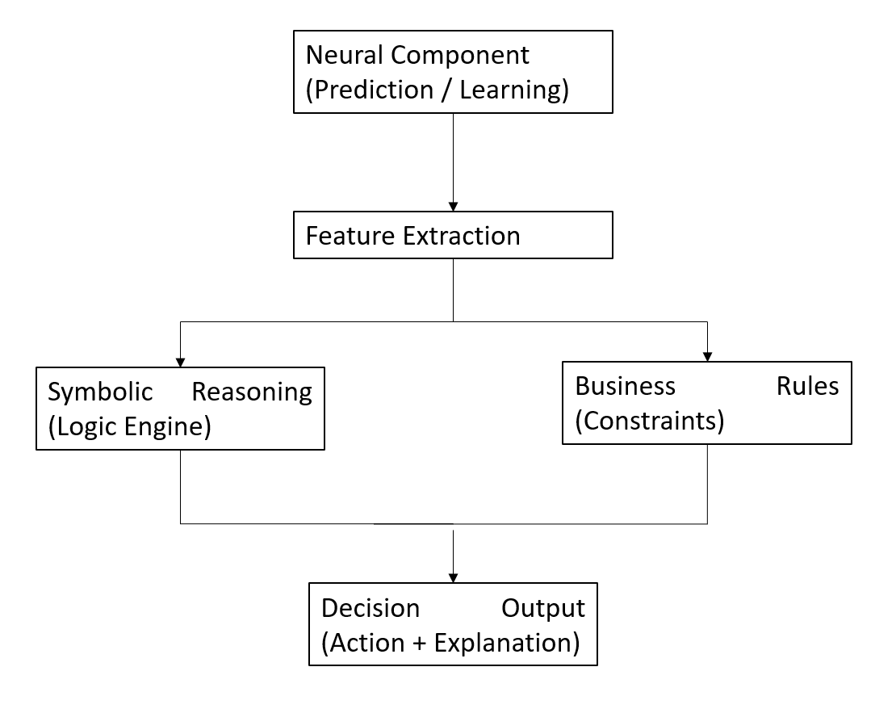
Figure 2.1: Neuro-Symbolic AI Architecture

Taxonomy of Neuro-Symbolic Architectures
The development of neuro-symbolic AI has resulted in several architectural approaches that combine learning and reasoning in different ways. Recent systematic reviews classify these architectures according to the level of integration between neural and symbolic components (Himabindu et al., 2023; Shakarian et al., 2023).
One important category consists of unified neuro-symbolic frameworks, where neural learning and symbolic reasoning are jointly optimised within a single architecture. These systems enable knowledge constraints to influence the learning process while allowing learned representations to improve reasoning performance. Such approaches reduce the separation between perception and reasoning tasks and provide stronger integration of symbolic knowledge.
A second category involves shared-backbone architectures, where neural models generate latent representations that are subsequently processed by symbolic reasoning modules. This design allows the system to benefit from advanced machine learning techniques while maintaining explicit logical reasoning capabilities.
Another important research direction focuses on knowledge-centric neuro-symbolic systems, which integrate external knowledge bases, ontologies, and causal relationships into AI models. Rather than relying solely on statistical correlations, these architectures incorporate domain expertise to improve interpretability and reduce the influence of spurious patterns.
Recent studies have also explored agentic and intent-aware neuro-symbolic systems, where recommendations are generated according to high-level objectives and contextual requirements. Instead of optimising a single mathematical objective, these systems attempt to align decisions with organisational goals and environmental conditions.
Neuro-symbolic Artificial Intelligence has developed through multiple architectural approaches that integrate neural learning with symbolic reasoning in different ways. Although these architectures demonstrate significant improvements in explainability and logical consistency, their application to SME marketing decision support remains limited. Table 2.2 presents a comparison of representative neuro-symbolic AI architectures identified in the literature.
Knowledge-centric neuro-symbolic systems focus on integrating external knowledge bases into machine learning models, whereas unified neuro-symbolic architectures attempt to jointly optimise learning and reasoning processes. Although these approaches differ technically, both aim to reduce the limitations associated with purely statistical AI systems.
Table 2.2: Representative Neuro-Symbolic AI Architectures
Study / Approach | Domain | Main Contribution | Limitation
Unified Neuro-Symbolic Frameworks | General AI | Integrates learning and reasoning in a single architecture | High implementation complexity
Knowledge-Centric Neuro-Symbolic Systems | Knowledge representation | Combines external knowledge with machine learning | Extensive knowledge engineering required
Shared-Backbone Architectures | Multi-task learning | Reuses learned representations across reasoning tasks | Limited interaction between symbolic and neural modules
Agentic and Intent-Aware Systems | Autonomous decision-making | Aligns recommendations with high-level objectives | Limited SME marketing applications
Causal Neuro-Symbolic Systems | Decision support | Improves robustness through causal reasoning | Often evaluated only on benchmark datasets
Proposed Framework | SME Marketing Decision Support | Combines predictive analytics, strategic intent, logic constraints, trust calibration, and structured explanations | Designed specifically for SME marketing environments
Source: Adapted from Shakarian et al. (2023), Himabindu et al. (2023), and related neuro-symbolic AI literature.

Table 2.2 indicates that existing neuro-symbolic architectures provide valuable capabilities such as knowledge integration, causal reasoning, and goal-oriented decision-making. Nevertheless, many studies focus on benchmark problems or specialised application domains, with relatively little attention given to SME marketing environments. Furthermore, trust calibration and strategic intent modelling are rarely integrated into these architectures, creating opportunities for future research.

Performance and Capabilities
The literature suggests that neuro-symbolic AI provides several advantages over purely data-driven approaches, particularly in decision-support applications.
First, neuro-symbolic systems improve interpretability by exposing the reasoning process behind recommendations. Unlike conventional black-box models, symbolic reasoning modules enable users to understand how domain knowledge and business rules contribute to final decisions. These characteristic supports auditing and managerial accountability.
Second, neuro-symbolic architectures facilitate the incorporation of business constraints into decision-making. Organisational policies, operational limitations, and strategic objectives can be represented explicitly as symbolic rules, ensuring that recommendations remain compatible with practical business requirements.
Third, symbolic reasoning can improve logical consistency. Pure machine learning models may occasionally generate recommendations that violate organisational policies or common-sense knowledge. By incorporating explicit reasoning mechanisms, neuro-symbolic systems can reduce such inconsistencies and produce more reliable outputs.
Another important capability is the support for causal and semantic reasoning. Rather than relying exclusively on statistical associations, neuro-symbolic approaches may integrate causal relationships and domain knowledge to improve robustness and reduce sensitivity to spurious correlations.
Recent engineering management research also indicates that neuro-symbolic systems can support human-AI collaboration by combining predictive evidence with understandable reasoning processes (Dellermann et al., 2019). Such capabilities are particularly relevant for SME managers who require transparent recommendations that can be justified and audited.
Despite these advantages, the literature also reveals that many existing neuro-symbolic applications focus on domains such as healthcare, robotics, scientific reasoning, and autonomous systems. Comparatively fewer studies investigate the application of neuro-symbolic AI to marketing decision support, especially in resource-constrained SME environments.

Limitations and Challenges
Although neuro-symbolic AI has demonstrated considerable potential, several research challenges remain.
One challenge concerns the development and maintenance of symbolic knowledge. Symbolic rules require domain expertise and careful design to ensure correctness and consistency. Poorly specified rules may introduce conflicts or reduce system flexibility.
Another challenge relates to the use of hard-rule reasoning. Strict logical constraints may eliminate feasible alternatives and reduce the adaptability of decision-support systems. In practical business environments, decisions often involve balancing multiple objectives rather than satisfying absolute conditions. Consequently, recent research has increasingly explored soft-rule and weighted-rule approaches that permit graceful degradation instead of complete rule violation.
Scalability also represents an important concern. Integrating symbolic reasoning with large-scale machine learning systems may increase computational complexity and implementation effort. Many existing neuro-symbolic architectures have been evaluated primarily on benchmark datasets rather than real-world business applications.
Furthermore, current neuro-symbolic research often concentrates on improving reasoning and explainability while paying relatively little attention to trust calibration. Although recommendations may be logically consistent, users may still misuse AI outputs by over trusting incorrect recommendations or under trusting reliable ones. This indicates that explainability and symbolic reasoning alone are insufficient to guarantee effective human-AI collaboration.
Finally, systematic reviews reveal that few existing studies integrate predictive analytics, business intent modelling, symbolic constraints, trust calibration, and structured explanation generation into a unified decision-support framework specifically designed for SME marketing applications. Most existing approaches address these capabilities independently, leaving significant opportunities for future research.
The literature demonstrates that neuro-symbolic AI provides a promising foundation for developing transparent and logically consistent decision-support systems. Nevertheless, explainability and symbolic reasoning alone do not guarantee that users will interact with AI recommendations appropriately. Managers may still overtrust unreliable recommendations or reject useful advice despite receiving understandable explanations. Consequently, effective decision-support systems must also address the challenge of trust calibration and human-AI collaboration. The following section reviews the theoretical foundations of trust calibration and its role in trustworthy artificial intelligence.
Existing neuro-symbolic research has primarily concentrated on improving reasoning performance and explainability. However, compared with studies on human-AI collaboration, relatively little attention has been given to the calibration of user trust and appropriate reliance on AI recommendations.

Trust Calibration and Human-AI Decision-Making

The Problem of Overtrust and Undertrust
The increasing adoption of Artificial Intelligence (AI) in business environments has transformed the role of decision-support systems from simple analytical tools into active participants in managerial decision-making. AI systems are now capable of generating predictions, identifying patterns, and recommending actions across a wide range of domains. However, the effectiveness of AI-assisted decision support depends not only on prediction accuracy but also on the quality of human-AI interaction.
Research in human factors and intelligent systems has consistently shown that users may develop inappropriate levels of trust toward automated systems. Lee and See (2004) define trust in automation as the attitude that an automated system will help achieve an individual's goals under conditions characterised by uncertainty and vulnerability. When trust is not aligned with the actual capability of the system, users may either overtrust or undertrust AI-generated recommendations.
Overtrust occurs when users accept AI recommendations without sufficient critical evaluation, even when the recommendations are incorrect. Excessive reliance on automation may reduce human oversight and increase the likelihood of poor decision-making, particularly in situations involving uncertainty or unexpected conditions (Lee & See, 2004). In business environments, overtrust may result in inappropriate marketing investments, inefficient resource allocation, or strategic decisions that expose organisations to unnecessary risks.
Conversely, undertrust occurs when users reject or ignore AI recommendations despite the system providing accurate and useful information. Undertrust reduces the practical benefits of AI technologies because managers may revert to intuition-based decision-making rather than utilising available analytical evidence (Green & Chen, 2019).
Recent empirical studies indicate that both overtrust and undertrust remain significant challenges for AI-assisted decision support. Human users do not always calibrate their confidence according to the actual reliability of AI systems, leading to decision behaviours that are inconsistent with objective system performance (Schemmer et al., 2023). Consequently, improving prediction accuracy alone is insufficient to ensure effective human-AI collaboration.
For SMEs, these challenges are particularly important because marketing decisions frequently involve financial uncertainty, limited resources, and dynamic market conditions. Managers require AI systems that not only provide recommendations but also communicate the degree of confidence that should be placed in those recommendations.
Lee and See (2004) established the theoretical foundations of trust in automation, whereas Green and Chen (2019) empirically demonstrated that users may still exhibit inappropriate reliance even when algorithmic support is available. Together, these studies suggest that trust must be actively calibrated rather than assumed.

Limitations of Explainability Alone
Explainable Artificial Intelligence (XAI) has emerged as an important research area that seeks to improve the transparency and interpretability of machine learning systems. XAI techniques provide insights into the reasoning process of AI models by identifying the features or factors that influence predictions (Barredo Arrieta et al., 2020).
Popular explanation methods, such as feature importance analysis and local explanation models, enable users to understand why a prediction was generated (Ribeiro et al., 2016). These approaches improve transparency and can increase user confidence by exposing the internal logic of otherwise opaque machine learning models.
Despite these benefits, recent studies suggest that explainability alone does not guarantee appropriate reliance on AI systems. Green and Chen (2019) demonstrated that users may continue to overtrust or undertrust automated recommendations even when explanations are provided. In some cases, the presence of an explanation may create a false sense of security, encouraging users to accept incorrect recommendations without adequate evaluation.
Similarly, studies on human-AI collaboration indicate that users may ignore explanations because they require additional cognitive effort or because the explanations are not presented in a form that supports practical decision-making (Kaur et al., 2020). Therefore, transparency should not be interpreted as a complete solution to trust-related challenges.
Another limitation is that many explanation techniques focus on describing model behaviour rather than communicating uncertainty. An explanation may clarify which factors contributed to a recommendation, but it does not necessarily indicate whether the recommendation is likely to be correct or whether additional human judgement is required.
Recent research therefore argues that explainability should be complemented by mechanisms that communicate uncertainty and support appropriate reliance (Vasconcelos et al., 2023). Decision-support systems should help users understand not only why a recommendation was generated but also how much confidence they should place in that recommendation.
Ribeiro et al. (2016) proposed explanation techniques for improving model transparency, whereas Kaur et al. (2020) investigated how practitioners actually use interpretability tools in real-world settings. Their findings indicate that explanations alone may not guarantee effective human-AI collaboration.

Trust Calibration Mechanisms
Trust calibration refers to the process of aligning user confidence with the actual reliability of an AI system. Rather than encouraging users to either blindly accept or completely reject AI recommendations, trust calibration seeks to establish an appropriate level of reliance based on objective system performance.
One commonly adopted approach involves probability calibration, where predicted confidence scores are adjusted to better reflect actual prediction accuracy. Guo et al. (2017) demonstrated that modern neural networks often produce poorly calibrated confidence estimates, making them appear more certain than they should be. Calibration methods, such as temperature scaling, have been proposed to reduce this discrepancy.
The quality of confidence calibration can be evaluated using metrics such as Expected Calibration Error (ECE), which measures the difference between predicted confidence and observed accuracy across multiple reliability intervals (Guo et al., 2017). Lower ECE values indicate that system confidence is more closely aligned with actual performance.
In addition to technical calibration metrics, recent human-centred AI research has introduced behavioural measures that evaluate the relationship between user trust and recommendation quality. Schemmer et al. (2023) argue that effective AI systems should minimise both overtrust and undertrust by ensuring that human confidence appropriately reflects system capability.
Trust calibration also supports responsible AI by encouraging meaningful human oversight. Instead of replacing managerial judgement, calibrated AI systems communicate uncertainty and encourage users to apply additional scrutiny when confidence is low. Such an approach is particularly suitable for decision-support applications where final responsibility remains with human decision-makers.
For business environments, trust calibration mechanisms may include calibrated confidence scores, uncertainty indicators, reliability categories, and recommendation quality estimates. These mechanisms help managers understand the limitations of AI outputs and reduce the likelihood of inappropriate reliance.
Trustworthy AI depends not only on prediction accuracy but also on appropriate human reliance. Various trust calibration mechanisms have been proposed to improve transparency, communicate uncertainty, and reduce the risks of overtrust and undertrust. Table 2.3 summarises the principal trust calibration mechanisms discussed in the literature.
Table 2.3: Trust Calibration Mechanisms in Human-AI Decision Support
Mechanism | Purpose | Strength | Limitation
Explainable AI (XAI) | Improve transparency | Helps users understand predictions | Does not guarantee appropriate trust
Feature Attribution Methods | Identify influential factors | Easy to interpret | May oversimplify complex models
Confidence Estimation | Indicates prediction reliability | Supports uncertainty awareness | Raw confidence may be poorly calibrated
Probability Calibration | Aligns confidence with actual accuracy | Reduces overconfidence | Requires additional calibration process
Structured Explanations | Standardises recommendation interpretation | Improves managerial understanding | Does not quantify uncertainty
Trust Calibration Framework | Balances user trust with system capability | Reduces overtrust and undertrust | Limited integration with business decision support
Proposed Approach | Combines calibrated confidence with structured explanations | Supports trustworthy human-AI collaboration | Requires integration of multiple AI components
Source: Adapted from Lee and See (2004), Guo et al. (2017), Green and Chen (2019), Kaur et al. (2020), Schemmer et al. (2023), and Vasconcelos et al. (2023).
As illustrated in Table 2.3, existing trust calibration mechanisms provide complementary benefits but also exhibit individual limitations. Explainable AI improves transparency, confidence estimation communicates uncertainty, and structured explanations enhance managerial understanding. However, these mechanisms are frequently implemented independently. Integrating calibrated confidence estimation with structured explanations may provide a more comprehensive approach for trustworthy decision support.
Guo et al. (2017) focused on the technical calibration of neural network confidence scores, whereas Schemmer et al. (2023) examined trust calibration from a behavioural human-AI interaction perspective. These complementary viewpoints suggest that trustworthy AI requires both accurate uncertainty estimation and appropriate human reliance.

Structured Explanations for Decision Support
In addition to confidence calibration, effective human-AI collaboration requires explanations that are understandable and useful in practical decision-making contexts. Unstructured explanations may provide technical information but often fail to support managerial reasoning.
Structured explanation frameworks organise AI outputs into predefined components that communicate the essential elements of the decision process. Such approaches improve consistency and facilitate auditing because recommendations are presented in a standardised format.
Research on explainable decision-support systems suggests that structured explanations should not merely describe model behaviour but should also communicate business implications and practical considerations (Kaur et al., 2020). In managerial environments, explanations should assist users in understanding the rationale behind recommendations while preserving their ability to exercise independent judgement.
For marketing decision support, a structured explanation may consist of four components:
- Driver – the primary factors influencing the recommendation.
- Implication – the expected business consequence.
- Action – the recommended managerial response.
- Caveat – the limitations, uncertainty, or risks associated with the recommendation.
This format enables managers to evaluate recommendations systematically while maintaining awareness of uncertainty and operational constraints.
Recent studies on collaborative AI systems further suggest that combining structured explanations with calibrated confidence estimates can improve the quality of human-AI interaction (Vasconcelos et al., 2023). Users are more likely to develop appropriate trust when they understand both the reasoning process and the reliability of the recommendation.
For SME marketing applications, structured explanations and trust calibration are particularly important because decisions often involve financial risks and uncertain market conditions. Transparent communication of evidence and uncertainty can improve managerial confidence while preserving human control over final decisions.
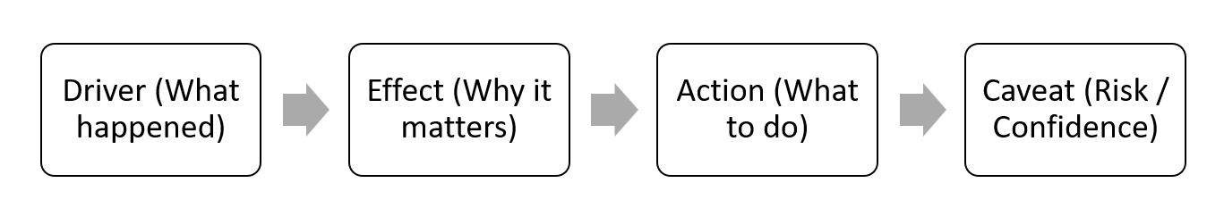
Figure 2.2: Structured Explanation Framework
Critical Synthesis
The literature indicates that prediction accuracy and explainability are necessary but insufficient conditions for effective AI-assisted decision support. While XAI improves transparency, empirical studies demonstrate that explanations alone cannot prevent inappropriate reliance on automated recommendations. Likewise, calibrated confidence scores provide information regarding uncertainty but may not fully support managerial understanding without accompanying explanations.
Existing research generally investigates explainability and trust calibration as separate problems. Relatively few studies integrate prediction, symbolic reasoning, confidence calibration, and structured explanation into a unified decision-support architecture. Furthermore, evidence regarding the application of these mechanisms in SME marketing remains limited.
These observations justify the inclusion of a dedicated trust calibration module and structured explanation component within the proposed intent-aware logic-constrained neuro-symbolic decision support system. By combining calibrated confidence estimation with standardised explanation templates, the proposed system seeks to support appropriate human reliance while preserving managerial accountability.
The preceding sections reviewed the limitations of existing marketing analytics, the emergence of neuro-symbolic artificial intelligence, and the importance of trust calibration for human-AI collaboration. Although these research areas have developed rapidly, the literature reveals that they are often investigated independently. The following section synthesises these findings, identifies the remaining research gaps, and justifies the design of the proposed decision-support system.

Research Gaps and Justification of Proposed System

Synthesis of Existing Literature
The preceding sections reviewed the development of marketing analytics, neuro-symbolic artificial intelligence, and trust calibration in human-AI decision support. Collectively, the literature demonstrates that substantial progress has been achieved in predictive modelling, explainable AI, and intelligent decision-support systems. However, these research streams have largely evolved independently, creating several unresolved challenges that limit their practical application in SME marketing environments.
Marketing analytics research has primarily concentrated on prediction and attribution. Machine learning models have significantly improved the ability to forecast customer behaviour and campaign outcomes, while attribution models have enhanced the understanding of multi-channel customer journeys (Wedel & Kannan, 2016; Berman, 2018). Nevertheless, these approaches typically stop at analytical interpretation and rarely provide direct recommendations regarding appropriate managerial actions.
Neuro-symbolic AI has emerged as a promising solution for integrating data-driven learning with explicit reasoning mechanisms. Existing studies demonstrate that combining neural learning and symbolic knowledge can improve interpretability, logical consistency, and constraint awareness (Shakarian et al., 2023; Himabindu et al., 2023). However, most neuro-symbolic research has focused on technical benchmark problems, healthcare, robotics, and scientific reasoning, with relatively limited attention given to SME marketing decision support.
Similarly, trust calibration research has established that explainability alone cannot ensure appropriate human reliance on AI recommendations (Green & Chen, 2019; Schemmer et al., 2023). Confidence estimation and uncertainty communication have therefore become increasingly important for responsible AI deployment. Despite these developments, trust calibration mechanisms are frequently studied separately from symbolic reasoning and business decision support.
The literature therefore suggests that an opportunity exists to integrate these complementary research areas into a unified framework that supports transparent, trustworthy, and actionable marketing decision-making.

Identified Research Gaps
Based on the literature synthesis, five major research gaps are identified.
Gap 1: The Attribution-to-Action Gap
Existing marketing analytics platforms are highly effective at generating predictions and measuring campaign performance but often fail to transform analytical outputs into actionable managerial recommendations. Attribution models identify important channels and customer interactions, yet the responsibility for determining appropriate actions remains largely with human decision-makers (Li & Kannan, 2014; Anderl et al., 2016).
This limitation is particularly significant for SMEs because managers frequently require practical guidance regarding whether marketing investments should be increased, maintained, reduced, or further investigated. Current analytical systems provide evidence but do not consistently support decision execution.
Gap 2: Limited Integration of Strategic Intent
Most existing optimisation models attempt to maximise predefined mathematical objectives without considering the broader strategic context of the organisation. However, business objectives may vary according to organisational circumstances. An SME focused on survival may require conservative recommendations, whereas a rapidly growing organisation may prioritise expansion and market penetration.
The literature indicates that relatively few AI-driven marketing systems explicitly model organisational intent as part of the decision-making process. As a result, recommendations generated by conventional optimisation algorithms may not align with actual business priorities.
Gap 3: Insufficient Constraint-Aware Reasoning
Although symbolic reasoning enables the incorporation of domain knowledge and organisational policies, many existing decision-support systems continue to rely primarily on statistical optimisation. Practical business decisions often involve constraints related to budget allocation, operational capacity, marketing policies, and acceptable risk levels.
Current machine learning approaches rarely integrate these business rules into the recommendation process. Consequently, recommendations may be analytically valid but operationally infeasible. Existing neuro-symbolic studies also provide limited evidence regarding the application of weighted business rules within SME marketing environments.
Gap 4: Separation Between Explainability and Trust Calibration
The literature demonstrates that explainability improves transparency but does not necessarily ensure appropriate reliance on AI recommendations (Kaur et al., 2020; Vasconcelos et al., 2023). Likewise, confidence calibration methods improve uncertainty estimation but may not sufficiently support managerial understanding when implemented independently.
Most existing studies investigate explainability and trust calibration as separate research problems. Few decision-support frameworks integrate structured explanations with calibrated confidence estimation to support trustworthy human-AI collaboration.
Gap 5: Lack of Unified Frameworks for SME Marketing Decision Support
Perhaps the most significant gap identified in the literature is the absence of an integrated framework that combines predictive analytics, strategic intent modelling, symbolic reasoning, trust calibration, and structured explanation generation within a single decision-support architecture.
Existing research typically addresses these components independently, resulting in fragmented solutions that only partially address the practical challenges faced by SME managers. The lack of unified architectures limits the ability of AI systems to provide recommendations that are simultaneously data-driven, logically consistent, strategically aligned, and trustworthy.

Justification of the Proposed System
The identified research gaps provide the theoretical and practical justification for the development of the proposed Intent-Aware Logic-Constrained Neuro-Symbolic Decision Support System with Trust Calibration.
First, the proposed system addresses the attribution-to-action gap by transforming analytical outputs into actionable recommendations rather than limiting system functionality to prediction and attribution. The objective is to support managerial decision-making by generating practical next-best actions based on available evidence.
Second, the system incorporates an intent-aware component that allows recommendations to be aligned with organisational priorities. Instead of assuming that all businesses share identical objectives, the proposed framework recognises that decision strategies may differ according to business goals such as survival, retention, or growth.
Third, the framework integrates logic-constrained reasoning to ensure that recommendations remain compatible with organisational policies and practical business constraints. Rather than relying solely on statistical optimisation, the proposed approach combines predictive evidence with symbolic knowledge to improve logical consistency and operational feasibility.
Fourth, the system incorporates trust calibration mechanisms to reduce inappropriate reliance on AI recommendations. Calibrated confidence estimation and uncertainty communication are intended to help managers understand the reliability of system outputs and determine when additional human judgement is required.
Finally, the framework employs structured explanation generation to improve transparency and support auditing. Standardised explanation templates enable users to understand the primary drivers of recommendations, expected business implications, suggested actions, and associated limitations.
To further illustrate the contribution of the proposed research, Table 2.4 compares the capabilities of existing marketing analytics systems and neuro-symbolic approaches with the proposed intent-aware logic-constrained neuro-symbolic decision support framework. The comparison demonstrates how the proposed system integrates multiple capabilities that are often studied independently in the existing literature.
Table 2.4: Comparison between Existing Systems and Proposed Framework
Capability | Traditional Marketing Analytics | Existing Neuro-Symbolic Systems | Proposed Framework
Predictive Analytics | ✓ | ✓ | ✓
Marketing Attribution | ✓ | Limited | ✓
Action Recommendation | Limited | Partial | ✓
Strategic Intent Awareness | ✗ | Limited | ✓
Business Rule Integration | ✗ | ✓ | ✓
Logic-Constrained Reasoning | ✗ | ✓ | ✓
Trust Calibration | ✗ | ✗ | ✓
Confidence Estimation | ✗ | Limited | ✓
Structured Explanation | Partial | Partial | ✓
Human-in-the-Loop Decision Support | Limited | Partial | ✓
SME Marketing Focus | Limited | Limited | ✓

As shown in Table 2.4, existing marketing analytics solutions primarily emphasise prediction and attribution, whereas neuro-symbolic systems improve reasoning and knowledge integration. However, relatively few existing approaches combine predictive intelligence, strategic intent modelling, business rule enforcement, trust calibration, and structured explanation within a single SME-oriented decision-support framework. The proposed system addresses this limitation by integrating these complementary capabilities into a unified architecture designed to support transparent and trustworthy marketing decision-making.
Unlike many existing decision-support systems, the proposed framework does not seek to replace human decision-makers. Instead, it adopts a human-centred approach that supports managerial judgement through transparent, trustworthy, and context-aware recommendations.

Research Contribution
Based on the identified gaps, the proposed research is expected to contribute to both engineering management research and practical SME marketing decision support.
From a theoretical perspective, the study contributes by integrating concepts from marketing analytics, neuro-symbolic artificial intelligence, and trust calibration into a unified decision-support framework.
From a technical perspective, the study contributes by developing an intent-aware architecture that combines predictive analytics with logic-constrained reasoning and calibrated recommendation generation.
From a practical perspective, the framework is designed to support SME managers by providing actionable recommendations that consider organisational objectives, business constraints, and uncertainty information.
The review of existing literature reveals several unresolved issues that limit the practical adoption of intelligent decision-support systems in SME marketing. These issues arise from the separation of predictive analytics, symbolic reasoning, and trust management research. Table 2.5 summarises the major research gaps identified in this study and explains how the proposed framework addresses these limitations.
Table 2.5 Summary of Research Gaps and Proposed Contributions
Research Gap | Existing Limitation | Impact on SMEs | Proposed Contribution
Attribution-to-action gap | Analytics produce predictions but not decisions | Managers must manually interpret results | Generate actionable next-best actions
Lack of strategic intent modelling | Generic optimisation objectives | Recommendations may not align with business priorities | Intent-aware recommendation engine
Limited business constraint integration | Few systems incorporate organisational rules | Operationally impractical recommendations | Logic-constrained reasoning
Explainability without calibrated trust | Transparency alone cannot prevent misuse | Risk of overtrust and undertrust | Trust calibration with uncertainty communication
Fragmented AI architectures | Prediction, reasoning, and trust handled separately | Increased complexity and reduced usability | Unified neuro-symbolic decision-support framework
Limited SME-focused solutions | Existing studies target large enterprises or benchmark datasets | Poor applicability to SMEs | SME-oriented marketing decision support
Source: Synthesised from the literature reviewed in Chapter 2.
Table 2.5 demonstrates that current research provides strong foundations in predictive analytics, neuro-symbolic reasoning, and trust calibration but lacks an integrated framework that combines these capabilities within a single SME-oriented decision-support system. The proposed Intent-Aware Logic-Constrained Neuro-Symbolic Decision Support System with Trust Calibration seeks to bridge these gaps by generating actionable recommendations that are strategically aligned, logically consistent, and trustworthy. These identified gaps provide the theoretical justification for the research methodology and system architecture presented in the following chapter.
Critical Synthesis
The literature demonstrates that significant advances have been achieved in marketing analytics, explainable AI, neuro-symbolic reasoning, and trust calibration. Nevertheless, these advances have largely been developed as independent research directions. Existing systems often provide accurate predictions, understandable explanations, or logical reasoning, but rarely integrate all of these capabilities into a unified framework for practical SME marketing decision support.
This fragmentation creates an opportunity to develop a decision-support architecture that combines predictive intelligence, symbolic reasoning, strategic intent modelling, trust calibration, and structured explanation generation. The proposed system seeks to address this opportunity by bridging the gap between analytical evidence and practical managerial action while preserving human oversight and accountability.
Overall, the literature indicates a gradual evolution from descriptive analytics towards intelligent decision-support systems. Nevertheless, existing studies often address prediction, reasoning, explainability, and trust calibration as separate research problems. The absence of an integrated framework that simultaneously considers strategic intent, business constraints, and calibrated human-AI collaboration represents a significant research opportunity. Therefore, this study proposes a unified neuro-symbolic decision-support architecture to bridge the attribution-to-action gap and improve trustworthy marketing decision-making for SMEs.
While neuro-symbolic AI research has improved reasoning capability and trust calibration research has enhanced human-AI collaboration, these fields have generally evolved independently. Few studies integrate predictive analytics, symbolic reasoning, and calibrated trust within a unified SME marketing decision-support framework.

Chapter Summary and Evaluation
This chapter reviewed the literature related to marketing analytics, neuro-symbolic artificial intelligence, and trust calibration in human-AI decision support. Existing marketing analytics systems provide valuable predictive and attribution capabilities but frequently fail to generate actionable recommendations suitable for practical managerial decision-making.
The review also demonstrated that neuro-symbolic AI provides a promising mechanism for integrating data-driven learning with explicit reasoning, thereby improving interpretability and logical consistency. However, current applications remain limited in SME marketing environments and often neglect strategic intent and trust calibration.
Furthermore, the literature indicates that explainability alone is insufficient to ensure appropriate reliance on AI systems. Trust calibration mechanisms and structured explanations are necessary to support responsible human-AI collaboration and reduce the risks of overtrust and undertrust.
Based on the synthesis of existing studies, five major research gaps were identified, including the attribution-to-action gap, limited strategic intent modelling, insufficient constraint-aware reasoning, separation between explainability and trust calibration, and the lack of unified decision-support frameworks.
These findings provide the theoretical foundation for the proposed Intent-Aware Logic-Constrained Neuro-Symbolic Decision Support System with Trust Calibration. The following chapter presents the research methodology, system architecture, and implementation approach adopted to address these identified gaps.

Chapter 3

Methodology and Requirements Analysis

Methodology and Requirements Analysis

Introduction
This chapter presents the methodology and requirements analysis for the development of the proposed Intent-Aware Logic-Constrained Neuro-Symbolic Decision Support System with Trust Calibration. Building upon the research gaps identified in Chapter 2, this chapter translates the theoretical concepts into a practical system development and evaluation framework.
The proposed research adopts a design-oriented and experiment-driven methodology that focuses on developing and validating an AI-assisted decision support artefact for SME multi-channel marketing. The methodology integrates predictive analytics, weighted soft-rule reasoning, strategic intent modelling, trust calibration, and structured explanation generation into a unified system architecture.
Unlike conventional software projects that evaluate only the final system performance, this research follows an ablation-first evaluation strategy. Individual system components are implemented and assessed incrementally to determine their respective contributions to recommendation quality, logical consistency, contextual relevance, and appropriate human reliance. This approach enables the study to establish whether improvements are genuinely attributable to specific architectural components rather than incidental implementation factors.
In addition to technical evaluation, the proposed methodology incorporates human-centred assessment to examine the practical usefulness of the generated recommendations. Recommendation actionability, trust alignment, explanation quality, and overall user acceptance are considered alongside conventional performance metrics to ensure that the system remains suitable for real-world SME decision-making environments.
The remainder of this chapter presents the research methodology, experimental framework, system development strategy, data preparation process, system components, evaluation methodology, requirement gathering techniques, and system requirements analysis that collectively guide the implementation and validation of the proposed framework.

Research Methodology Overview

Research Approach
This research adopts a quantitative experimental methodology supported by human-centred evaluation principles. The objective is not only to develop an intelligent decision support system but also to empirically evaluate the contribution of each architectural component to the overall system performance.
The methodology combines system development, controlled experimentation, and comparative evaluation. The proposed framework is implemented as a modular decision support pipeline, where predictive analytics, symbolic reasoning, strategic intent modelling, trust calibration, and explanation generation are developed as independent but interconnected components.
The methodology consists of four major activities: system development and ablation testing, benchmark dataset construction, comparative evaluation against baseline approaches, and human-centred evaluation of trust and recommendation actionability.
This approach ensures that the proposed framework is evaluated from both technical and managerial perspectives. Technical evaluation focuses on recommendation quality, logical consistency, and computational performance, whereas human evaluation examines user trust, recommendation actionability, and explanation usefulness.

Experimental Design Framework
The experimental framework is designed to evaluate the contribution of individual system components through controlled ablation studies. Rather than comparing only complete systems, the proposed methodology systematically removes or modifies architectural modules to observe their impact on overall performance.
The experimental design consists of four major components:
  - Baseline systems;
  - Proposed system variants;
  - Evaluation metrics; and
  - Ablation studies.
Baseline systems include heuristic scorecard methods, predictive-only models, attribution-only approaches, and post-hoc rule-based recommendation systems.
The proposed framework is evaluated incrementally through multiple architectural variants, including the predictive-attribution backbone, logic-constrained recommendation layer, intent-aware decision module, and trust calibration module.
Performance evaluation considers recommendation actionability, scenario-fit rate, logical conflict rate, Expected Calibration Error (ECE), trust alignment, overtrust rate, and system latency.
Ablation studies are conducted by selectively removing the logic layer, trust calibration module, or intent-aware component to determine the contribution of each module to the overall system performance. This methodology strengthens the internal validity of the research by establishing causal relationships between architectural components and observed outcomes.
Figure 3.1 Research Methodology Framework

System Development Methodology

Development Strategy
The proposed decision support system is developed using a modular architecture that allows individual components to be implemented, tested, and evaluated independently. This strategy improves maintainability and supports the experimental objectives of the research by enabling controlled ablation studies.
Unlike monolithic AI systems, the proposed framework separates predictive analysis, symbolic reasoning, strategic intent modelling, trust calibration, and explanation generation into distinct functional modules. Each module performs a specific task and contributes incrementally to the final recommendation process.
The development process consists of five major phases:
  - data preparation and preprocessing;
  - predictive-attribution modelling;
  - candidate action generation;
  - neuro-symbolic decision reasoning;
  - trust calibration and explanation generation.
The modular design allows architectural components to be added or removed during experimentation. Consequently, the research can evaluate the contribution of each module to recommendation quality, logical consistency, and user trust.
The system is implemented as a decision support application and does not perform autonomous marketing execution. All recommendations generated by the framework require human review and approval before any business action is taken.

System Pipeline Overview
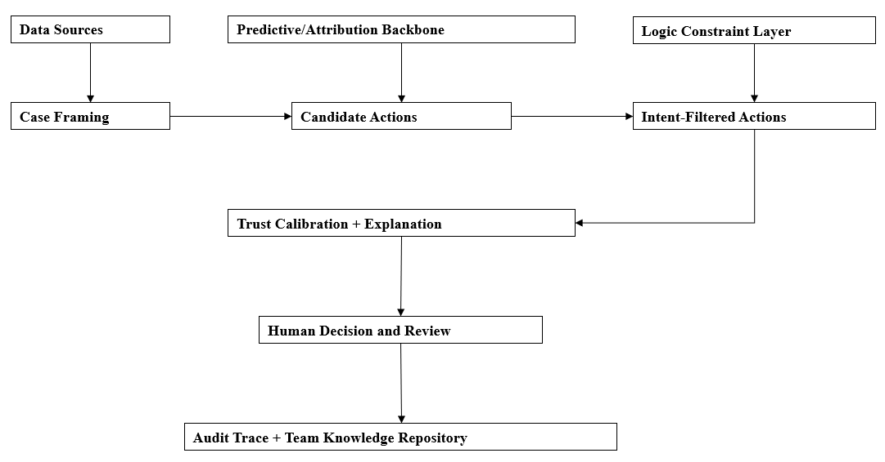Figure 3.2: Implementation Pipeline for Decision Support System
The proposed framework transforms marketing performance data into actionable recommendations through a sequence of analytical and reasoning processes. The overall system pipeline consists of six interconnected modules that progressively refine decision quality.
Initially, marketing performance indicators are collected and pre-processed to ensure data consistency and completeness. The predictive-attribution backbone then analyses campaign performance and customer engagement patterns to estimate the relative effectiveness of different marketing activities.
Based on these analytical outputs, the candidate action generation module produces a set of possible marketing actions. These actions may include increasing investment in high-performing channels, maintaining current strategies, reducing ineffective activities, or conducting further investigation.
The generated candidates are subsequently evaluated by the logic-constrained reasoning module. Business constraints and symbolic rules are applied to eliminate recommendations that violate organisational policies or operational limitations.
The intent-aware module further refines the recommendations by considering strategic business objectives. Different organisational priorities may produce different recommendation rankings even when analytical evidence remains identical.
The trust calibration module estimates the reliability of the generated recommendation and produces calibrated confidence scores. Finally, the explanation generation module creates structured explanations that communicate the rationale, expected implications, recommended actions, and associated uncertainties to the user.
This sequential pipeline enables the system to combine predictive intelligence, symbolic reasoning, and human-centred trust mechanisms within a unified decision-support architecture.

Data Requirements and Preparation

Dataset Requirements
The proposed decision support framework requires a structured marketing dataset that satisfies several minimum requirements to ensure sufficient analytical validity and meaningful cross-channel evaluation.
The dataset should satisfy the following conditions:
- Minimum of 500 campaign-period records;
- At least three marketing channels;
- Minimum observation period of six months; and
- At least one measurable business outcome variable, such as conversion rate, sales revenue, or customer acquisition.
These requirements are intended to provide adequate data diversity for predictive modelling and multi-channel attribution analysis.
If the minimum requirements cannot be fully satisfied, the experimental design adopts a simplified configuration. In such cases:
- the system will operate using a two-channel analytical variant; and
- conclusions regarding cross-channel interaction effects will be treated as exploratory findings rather than definitive evidence.
This fallback strategy improves the robustness of the research by allowing system evaluation to proceed while explicitly acknowledging dataset limitations.

Data Sources
This research utilises the Nykaa Marketing Campaign Performance Dataset obtained from Kaggle as the primary data source. The dataset contains historical marketing campaign records collected from multiple digital marketing channels and includes various performance indicators relevant to marketing decision-making. The dataset provides information on campaign characteristics, customer engagement metrics, acquisition costs, conversions, revenue generation, and return on investment (ROI).
The selected dataset was chosen because it contains attributes that are aligned with the objectives of this research, particularly for evaluating marketing effectiveness and generating data-driven recommendations. Key attributes utilised in this study include campaign type, target audience, marketing channel, impressions, clicks, leads, conversions, revenue, acquisition cost, ROI, engagement score, customer segment, language, and campaign date.
Prior to analysis, the dataset undergoes preprocessing procedures including data cleaning, handling of missing values, removal of duplicate records, and feature standardisation. Derived performance indicators such as ROI and engagement metrics are validated to ensure consistency before being used by the predictive attribution and neuro-symbolic reasoning components of the proposed framework.
The processed dataset serves as the primary input for campaign performance analysis, recommendation generation, trust calibration, and system evaluation throughout the study.

Decision Case Construction
To support neuro-symbolic decision-making, each campaign record is transformed into a structured decision case. A decision case represents a complete marketing scenario containing campaign characteristics, performance indicators, customer engagement measures, and business outcomes. The decision cases serve as the fundamental units for recommendation generation and evaluation.
Each decision case consists of campaign attributes including campaign type, target audience, marketing channel, impressions, clicks, leads, conversions, revenue, acquisition cost, ROI, engagement score, customer segment, language, and campaign date. In addition, each case is assigned a business intent category of Survival, Retention, or Growth based on predefined business objectives and campaign performance characteristics.
The resulting collection of decision cases is used by the predictive attribution module to estimate campaign effectiveness and by the logic-constrained reasoning module to generate explainable marketing recommendations. The structured representation also facilitates trust calibration and explanation generation within the proposed neuro-symbolic framework.

Data Splitting Strategy
The prepared dataset is divided into three subsets to support model development and evaluation:
- Training set – used for model learning and parameter estimation;
- Validation set – used for confidence calibration and parameter tuning; and
- Test set – used for final system evaluation.
To minimise the risk of data leakage, dataset splitting is performed according to either time period or business unit boundaries rather than through arbitrary random sampling. This strategy better reflects realistic business deployment scenarios and improves the reliability of the experimental results.
The separated datasets are subsequently used throughout the ablation experiments and comparative evaluation procedures described in the following sections.
Figure 3.3 Data Preparation Workflow

System Components
The proposed Intent-Aware Logic-Constrained Neuro-Symbolic Decision Support System with Trust Calibration consists of six major functional modules. Each module performs a specific role within the decision-support pipeline and contributes incrementally to the generation of actionable and trustworthy marketing recommendations.
The modular architecture enables individual components to be independently evaluated through ablation experiments while maintaining interoperability within the complete system framework. Figure 3.4 illustrates the interaction between the major system components.

Predictive-Attribution Backbone
The predictive-attribution backbone serves as the analytical foundation of the proposed framework. This module processes historical marketing data and estimates the relative effectiveness of different marketing activities and customer interactions.
The module analyses campaign performance indicators, customer engagement metrics, and business outcome variables to identify patterns associated with successful marketing strategies. Attribution analysis is further performed to estimate the contribution of multiple marketing channels to overall business outcomes.
Rather than directly generating final recommendations, the predictive-attribution backbone provides evidence that supports subsequent reasoning and decision-making modules.

Candidate Action Generation
Based on the analytical outputs produced by the predictive-attribution backbone, the candidate action generation module creates a set of possible managerial actions.
Representative candidate actions include:
- increase marketing investment;
- maintain current strategy;
- reduce resource allocation;
- optimise campaign configuration; and
- perform further investigation.
The purpose of this module is to transform predictive evidence into actionable alternatives that can subsequently be evaluated against organisational constraints and strategic objectives.
Multiple candidate actions may be generated simultaneously to provide managers with alternative decision options.

Weighted Soft-Rule Reasoning
The weighted soft-rule reasoning module evaluates candidate actions using predefined business rules and organisational constraints.
Unlike hard-rule systems that reject recommendations whenever a single constraint is violated, the proposed framework applies weighted rules that allow partial satisfaction of multiple conditions. This approach improves flexibility and better reflects practical business decision-making environments.
Examples of symbolic constraints include budget limitations, minimum campaign performance thresholds, channel suitability, and organisational policies.
Each candidate action receives a reasoning score based on the degree to which it satisfies the applicable business rules. Actions with higher scores are prioritised during the recommendation process.

Intent-Aware Decision Module
The intent-aware decision module aligns recommendations with organisational objectives. Analytical evidence alone may not produce identical recommendations under different business circumstances. Consequently, the proposed framework incorporates strategic intent as an additional decision factor.
Three business intent categories are considered:
- Survival;
- Retention; and
- Growth.
For example, a growth-oriented organisation may prioritise aggressive marketing expansion, whereas a survival-oriented organisation may prefer conservative resource allocation strategies.
The intent-aware module adjusts recommendation priorities according to the assigned business objective while preserving the analytical evidence generated by earlier modules.
Table 3.1: Strategies for each business intent
Intent | Strategy
Survival | Minimise risk, preserve cash
Retention | Maximise customer value
Growth | Invest aggressively

Trust Calibration Module
The trust calibration module estimates the reliability of generated recommendations and communicates appropriate confidence levels to users.
The module aims to reduce both overtrust and undertrust by aligning user confidence with the actual capability of the decision-support system. Confidence estimation and calibration techniques are applied to improve the consistency between predicted reliability and observed system performance.
In addition to calibrated confidence scores, the module may generate recommendation quality indicators that assist managers in determining whether additional human review is required.
This approach supports responsible AI adoption by encouraging informed human oversight rather than blind reliance on automated recommendations.

Structured Explanation Generation
The final module generates structured explanations that accompany each recommendation.
The explanation framework consists of four major components:
- Driver;
- Implication;
- Action; and
- Caveat.
The Driver identifies the primary factors influencing the recommendation. The Implication describes the expected business impact. The Action specifies the suggested managerial response, while the Caveat communicates uncertainty, limitations, or potential risks.
Structured explanations improve transparency, facilitate auditing, and strengthen human-AI collaboration by enabling users to understand both the rationale and limitations of system outputs.
Collectively, these six modules form an integrated neuro-symbolic decision-support framework that combines predictive intelligence, symbolic reasoning, strategic intent modelling, and trust calibration to support SME marketing decision-making.
Figure 3.4 System Component Architecture

Evaluation Methodology
The proposed framework is evaluated using a combination of quantitative performance assessment and human-centred evaluation. The objective is to determine whether the integration of predictive analytics, weighted soft-rule reasoning, strategic intent modelling, trust calibration, and structured explanation generation improves the quality and trustworthiness of marketing decision support.
Unlike conventional software evaluation that focuses solely on prediction accuracy, this research evaluates both technical performance and practical managerial usefulness.

Baseline Systems
To determine the effectiveness of the proposed framework, its performance is compared against several baseline approaches representing different levels of analytical capability.
The baseline systems include:
- Baseline A – Heuristic Scorecard
Traditional rule-based decision support using manually defined thresholds.
- Baseline B – Predictive Analytics Only
Recommendation generation based solely on predictive modelling without symbolic reasoning.
- Baseline C – Predictive Analytics with Attribution
Decision support based on predictive analysis and marketing attribution without strategic intent or trust calibration.
- Proposed Framework
Integration of predictive analytics, candidate action generation, weighted soft-rule reasoning, intent-aware decision modelling, trust calibration, and structured explanation generation.
The comparative evaluation enables the contribution of each architectural enhancement to be systematically assessed.

Ablation Study Design
An ablation study is conducted to evaluate the importance of individual system components.
The experiments progressively remove selected modules from the complete framework and measure the resulting performance changes.
The evaluated configurations include:
- Full proposed framework;
- Framework without trust calibration;
- Framework without intent-aware decision modelling;
- Framework without weighted soft-rule reasoning; and
- Predictive-attribution backbone only.
The purpose of the ablation study is to determine whether each architectural component contributes meaningfully to overall system performance.
To provide a systematic evaluation of the proposed architecture, several experimental configurations are constructed by selectively removing individual system components. Table 3.1 summarises the baseline systems and ablation variants used throughout the experimental evaluation.
Table 3.2: Ablation Study Configurations
Configuration | Predictive Backbone | Soft Rules | Intent Awareness | Trust Calibration | Explanation
Baseline A | ✗ | ✓ | ✗ | ✗ | ✗
Baseline B | ✓ | ✗ | ✗ | ✗ | ✗
Baseline C | ✓ | ✗ | ✗ | ✗ | Partial
Variant 1 | ✓ | ✓ | ✓ | ✗ | ✓
Variant 2 | ✓ | ✓ | ✗ | ✓ | ✓
Variant 3 | ✓ | ✗ | ✓ | ✓ | ✓
Proposed Framework | ✓ | ✓ | ✓ | ✓ | ✓

As shown in Table 3.1, the ablation study progressively removes selected architectural components to evaluate their individual contributions to the overall decision-support performance. By comparing these configurations, the research can determine whether weighted soft-rule reasoning, intent-aware decision modelling, and trust calibration provide measurable improvements over conventional predictive approaches.

Evaluation Metrics
The proposed framework is evaluated using both technical and human-centred metrics. The selected metrics are intended to assess multiple dimensions of system quality rather than focusing solely on prediction performance. Technical metrics evaluate recommendation correctness, logical consistency, calibrated uncertainty estimation, and computational efficiency, whereas human-centred metrics assess recommendation usefulness, transparency, and appropriate human-AI reliance.
The combination of these metrics provides a comprehensive assessment of both system effectiveness and practical usability. Table 3.2 summarises the evaluation metrics adopted in this research.
Table 3.2 Evaluation Metrics
Category | Metric | Purpose
Technical | Recommendation Accuracy | Evaluate correctness of recommendations
Technical | Scenario-Fit Rate | Measure alignment with business scenarios
Technical | Logical Conflict Rate | Measure rule violations
Technical | Expected Calibration Error (ECE) | Evaluate confidence calibration
Technical | Recommendation Latency | Measure processing efficiency
Human | Recommendation Actionability | Assess practical usefulness
Human | Trust Alignment | Measure appropriate reliance
Human | Explanation Usefulness | Evaluate transparency
Human | User Acceptance | Assess overall satisfaction

The evaluation metrics were selected to capture the multidimensional nature of trustworthy AI decision support. Recommendation accuracy and scenario-fit rate measure the quality of the generated recommendations, while logical conflict rate evaluates consistency with symbolic business constraints. Expected Calibration Error (ECE) assesses the effectiveness of the trust calibration mechanism by measuring the alignment between predicted confidence and actual system reliability.
Human-centred metrics complement the technical evaluation by examining recommendation actionability, trust alignment, explanation usefulness, and overall user acceptance. Recommendation latency is included to assess operational efficiency and the practicality of deploying the framework in real-world SME environments. Collectively, these metrics provide a balanced evaluation of recommendation quality, logical consistency, calibrated uncertainty estimation, human-AI trust alignment, transparency, and system efficiency.

Human Evaluation Procedure
A human-centred evaluation is conducted to assess the practical usefulness of the generated recommendations.
Participants are presented with benchmark marketing scenarios and corresponding AI-generated recommendations. They are asked to evaluate:
- relevance of the recommendation;
- appropriateness of the suggested action;
- clarity of the explanation;
- confidence in the recommendation; and
- overall usefulness for decision-making.
Responses are collected using a five-point Likert scale.
The human evaluation complements the quantitative experiments by examining whether the proposed framework successfully supports appropriate human-AI collaboration.

Statistical Analysis
Experimental results are summarised using descriptive statistical methods.
Performance metrics are compared across baseline systems and ablation variants to identify improvements associated with individual architectural components.
Where appropriate, mean values, standard deviations, and percentage improvements are reported to facilitate objective comparison.
The statistical analysis provides empirical evidence regarding the effectiveness of the proposed Intent-Aware Logic-Constrained Neuro-Symbolic Decision Support System with Trust Calibration.

Requirement Gathering Techniques

Overview
The requirements for the proposed Intent-Aware Logic-Constrained Neuro-Symbolic Decision Support System with Trust Calibration are gathered using a combination of literature-driven analysis and engineering design principles.
Unlike conventional information systems that primarily derive requirements from end-user interviews, the proposed framework addresses a research problem identified through systematic literature review and gap analysis. Consequently, the requirement gathering process focuses on translating identified research challenges into functional and technical system requirements.
The requirement gathering process consists of three major activities:
- literature analysis;
- problem analysis; and
- framework synthesis.

Literature Analysis
The first stage involves the analysis of existing research related to marketing analytics, neuro-symbolic artificial intelligence, explainable AI, and trust calibration.
The literature review conducted in Chapter 2 identifies several limitations in current decision-support systems, including:
- the attribution-to-action gap;
- limited strategic intent modelling;
- insufficient business constraint integration;
- lack of trust calibration mechanisms; and
- fragmented AI architectures.
These findings provide the theoretical foundation for defining the system requirements.

Problem Analysis
The second stage focuses on analysing the practical challenges encountered in SME marketing decision-making.
Existing marketing analytics platforms frequently provide predictive insights without generating actionable recommendations. Furthermore, many AI systems operate as black-box models that provide limited transparency and may encourage inappropriate user trust.
The identified business problems are translated into technical requirements that guide the design of the proposed framework.

Framework Synthesis
The final stage integrates the findings obtained from the literature review and problem analysis into a unified system architecture.
The proposed framework is designed to satisfy the following objectives:
- generate actionable recommendations;
- incorporate symbolic business constraints;
- align recommendations with strategic intent;
- calibrate user trust appropriately; and
- provide structured explanations.
The synthesis process ensures that each system component directly addresses one or more research gaps identified in Chapter 2.

Figure 3.6 Requirement Gathering Process

System Requirements Analysis

Functional Requirements
The proposed system shall provide the following functional capabilities:
FR1: Import and process marketing performance data.
FR2: Perform predictive-attribution analysis.
FR3: Generate candidate marketing actions.
FR4: Apply weighted soft-rule reasoning.
FR5: Support intent-aware recommendation generation.
FR6: Estimate calibrated recommendation confidence.
FR7: Generate structured explanations.
FR8: Display recommendations to users.
FR9: Allow users to review recommendation details.
FR10: Record recommendation outcomes for future evaluation.

Non-Functional Requirements
The proposed system shall satisfy the following non-functional requirements
Requirement | Description
Performance | Recommendation generation should complete within an acceptable response time.
Reliability | System outputs should remain logically consistent under similar input conditions.
Explainability | Recommendations shall include structured explanations.
Trustworthiness | Confidence estimates should be calibrated to reduce inappropriate reliance.
Maintainability | Individual modules should support independent modification.
Scalability | The framework should support future extension to additional marketing channels.
Security | Sensitive business information shall be protected from unauthorised access.
Usability | Recommendations should be understandable to SME managers.

Use Case Analysis
Primary Actor: SME Marketing Manager
Main Use Cases:
  - Upload marketing data
  - Analyse campaign performance
  - Generate recommendations
  - Review confidence score
  - Review explanation
  - Make final decision

System Constraints
The proposed system operates under several design constraints.
  - Human approval is required before action execution.
  - Direct integration with ERP and CRM platforms is outside the project scope.
  - The framework focuses on decision support rather than autonomous marketing execution.
  - Recommendation quality depends on the availability of sufficient historical marketing data.
  - The experimental evaluation is limited to benchmark decision cases.

Chapter Summary and Evaluation
This chapter presented the research methodology and system requirements for the development of the proposed Intent-Aware Logic-Constrained Neuro-Symbolic Decision Support System with Trust Calibration.
The chapter first introduced the overall research methodology, which combines quantitative experimentation with human-centred evaluation to assess both technical performance and practical managerial usefulness. The system development strategy and processing pipeline were subsequently described, illustrating how predictive analytics, candidate action generation, weighted soft-rule reasoning, intent-aware decision modelling, trust calibration, and structured explanation generation interact to produce actionable marketing recommendations.
The chapter also discussed the dataset requirements, data preparation procedures, decision case construction process, and data splitting strategy that support the experimental evaluation. In addition, the major system components were formally defined, and an evaluation methodology based on baseline comparison, ablation studies, technical metrics, and human evaluation was established.
Requirement gathering techniques and system requirements analysis were further presented to ensure that the proposed framework addresses the research gaps identified in Chapter 2 while remaining aligned with practical SME marketing needs.
Overall, the methodology presented in this chapter provides a systematic foundation for the implementation and validation of the proposed framework. The following chapter describes the detailed system design, architecture, and implementation of the developed decision support system.
Table 3.3 summarises the major methodological components discussed in this chapter and their respective roles in supporting the development and evaluation of the proposed framework.
Table 3.3 Summary of Chapter 3
Component | Purpose
Research Methodology | Define overall research approach
Development Strategy | Guide system implementation
Data Preparation | Ensure data quality
System Components | Describe framework architecture
Evaluation Methodology | Measure system performance
Requirement Gathering | Identify system needs
Requirements Analysis | Define functional and non-functional requirements

The methodological components summarised in Table 3.3 collectively establish a structured and reproducible process for developing and validating the proposed decision support system.

Chapter 4

System Design

System Design
This chapter presents the system design of the proposed Intent-Aware Logic-Constrained Neuro-Symbolic Decision Support System with Trust Calibration. Building upon the methodology established in Chapter 3, this chapter translates the proposed framework into a detailed architectural and technical design suitable for implementation.
The chapter describes the overall system architecture, processing workflow, Unified Modelling Language (UML) diagrams, database structure, algorithm design, and user interface design. These design components provide a blueprint for the implementation of the proposed decision support framework and ensure consistency between the identified requirements and the developed system.
The proposed architecture adopts a modular design strategy that separates predictive analytics, candidate action generation, logic-constrained reasoning, intent-aware decision modelling, trust calibration, and explanation generation into independent but interconnected components. This modular structure improves maintainability, scalability, and experimental flexibility.
The remainder of this chapter presents the detailed system design that supports the implementation and evaluation activities described in Chapter 5.

Overall System Architecture
The proposed system adopts a layered neuro-symbolic architecture that integrates data-driven prediction with symbolic reasoning and trust-aware decision support.
The architecture consists of six major modules that cooperate to transform marketing performance data into actionable and explainable recommendations. Each module performs a dedicated function while exchanging information with adjacent components through structured interfaces.
Marketing data are first collected and pre-processed before being analysed by the predictive-attribution backbone. Candidate marketing actions are then generated and evaluated against business rules using the logic-constrained reasoning module. The intent-aware decision module subsequently adjusts recommendation priorities according to organisational objectives. Trust calibration estimates recommendation reliability, and the explanation generation module provides transparent decision rationales to support managerial review.
The final decision remains under human control, ensuring that the proposed framework functions as a decision support system rather than an autonomous marketing execution platform.
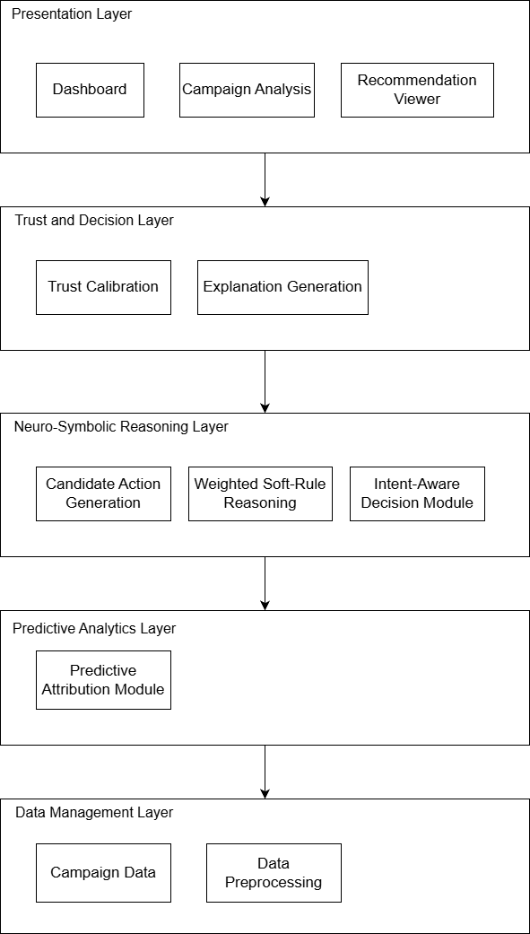
Figure 4.1 Overall System Architecture
Figure 4.1 presents the layered architecture of the proposed framework. Marketing data is processed by the predictive attribution module, followed by neuro-symbolic reasoning using weighted business rules and intent-aware decision-making. Trust calibration and explanation generation are subsequently applied before recommendations are presented to decision makers.

System Workflow Design

High-Level Workflow
The overall workflow of the proposed framework begins with the acquisition of marketing performance data. After preprocessing, predictive analysis identifies significant marketing patterns and channel contributions.
Based on these analytical outputs, candidate actions are generated and evaluated through symbolic business constraints. Strategic intent information is then incorporated to ensure that recommendations remain aligned with organisational objectives.
Trust calibration estimates the reliability of each recommendation, and structured explanations are generated to improve transparency and support managerial understanding. Finally, the user reviews the recommendation and determines the appropriate business action.

Figure 4.2 High-Level Workflow

UML Design

Class Diagram
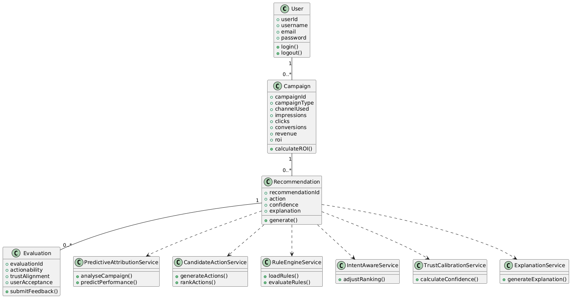

Use Case Diagram
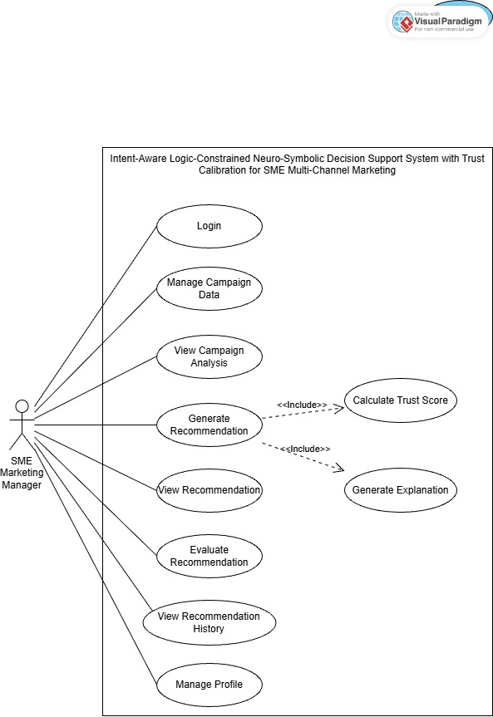
Figure 4.4 Use Case Diagram

Activity Diagram
The overall workflow of the proposed framework begins with the acquisition of marketing performance data. After preprocessing, predictive analysis identifies significant marketing patterns and channel contributions.
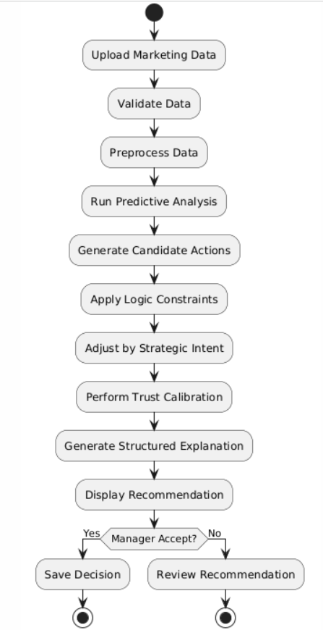

Sequence Diagram
The overall workflow of the proposed framework begins with the acquisition of marketing performance data. After preprocessing, predictive analysis identifies significant marketing patterns and channel contributions.
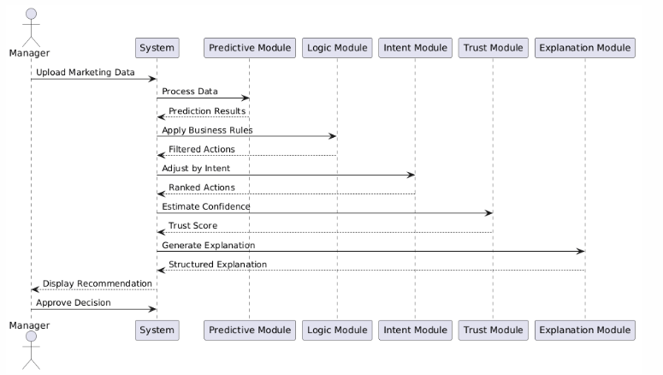

Database Design

ER Diagram
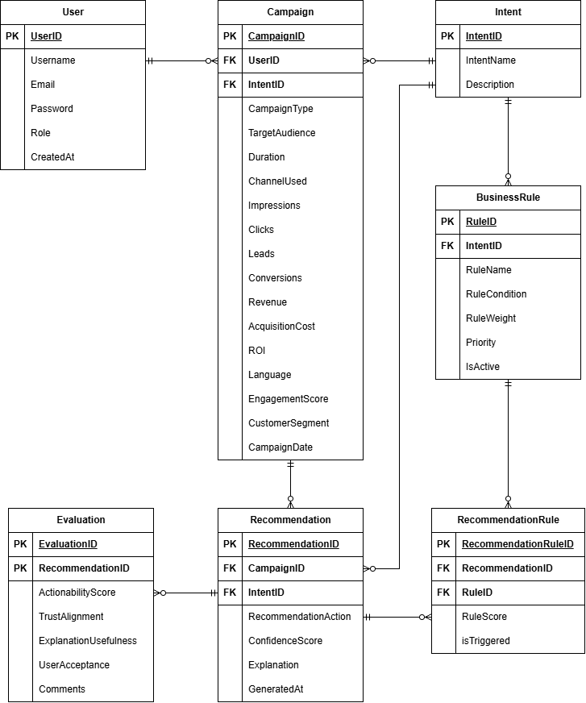

Database Schema
User
Field | Type
UserID (PK) | INT
Username | VARCHAR(100)
Email | VARCHAR(100)
Password | VARCHAR(255)
Role | VARCHAR(20)
CreatedAt | DATETIME

Campaign
Field | Type
CampaignID (PK) | VARCHAR(20)
UserID (FK) | INT
IntentID (FK) | INT
CampaignType | VARCHAR(50)
TargetAudience | VARCHAR(100)
Duration | INT
ChannelUsed | VARCHAR(50)
Impressions | INT
Clicks | INT
Leads | INT
Conversions | INT
Revenue | DECIMAL(12,2)
AcquisitionCost | DECIMAL(12,2)
ROI | DOUBLE
Language | VARCHAR(50)
EngagementScore | DOUBLE
CustomerSegment | VARCHAR(100)
CampaignDate | DATE

Intent
Field | Type
IntentID (PK) | INT
IntentName | VARCHAR(30)
Description | TEXT

Recommendation
Field | Type
RecommendationID (PK) | INT
CampaignID (FK) | VARCHAR(20)
IntentID (FK) | INT
RecommendedAction | TEXT
ConfidenceScore | DOUBLE
Explanation | TEXT
GeneratedAt | DATETIME

Evaluation
Field | Type
EvaluationID (PK) | INT
RecommendationID (FK) | INT
ActionabilityScore | DOUBLE
TrustAlignment | DOUBLE
ExplanationUsefulness | DOUBLE
UserAcceptance | DOUBLE
Comments | TEXT

Recommendation
Field | Type
RecommendationRuleID (PK) | INT
RecommendationID (FK) | INT
RuleID (FK) | INT
RuleScore | DOUBLE
IsTriggered | BOOLEAN

BusinessRule
Field | Type
RuleID (PK) | INT
IntentID (FK) | INT
RuleName | VARCHAR(100)
RuleCondition | TEXT
RuleWeight | DOUBLE
Priority | INT
IsActive | BOOLEAN

Algorithm Design

Algorithm 1: Predictive Attribution
Purpose
The Predictive Attribution algorithm analyses historical marketing campaign data to estimate campaign effectiveness and identify influential performance factors. The resulting performance score provides quantitative evidence for subsequent recommendation generation.
Detailed Description

The algorithm begins by loading campaign records from the database. The data is validated to ensure completeness and consistency before feature extraction is performed. Relevant marketing indicators, including impressions, clicks, conversions, engagement score, acquisition cost, and ROI, are used as predictive features. A predictive model is then applied to estimate campaign performance. The resulting score represents the expected effectiveness of the campaign and serves as input for candidate action generation.
Pseudocode
Algorithm PredictiveAttribution
Input: CampaignData
Output: PerformanceScore
BEGIN
Load CampaignData
IF CampaignData is empty THEN
Return Error
END IF
Preprocess CampaignData
Validate Data Quality
Extract Features
Apply Predictive Model
Calculate PerformanceScore
Return PerformanceScore
END
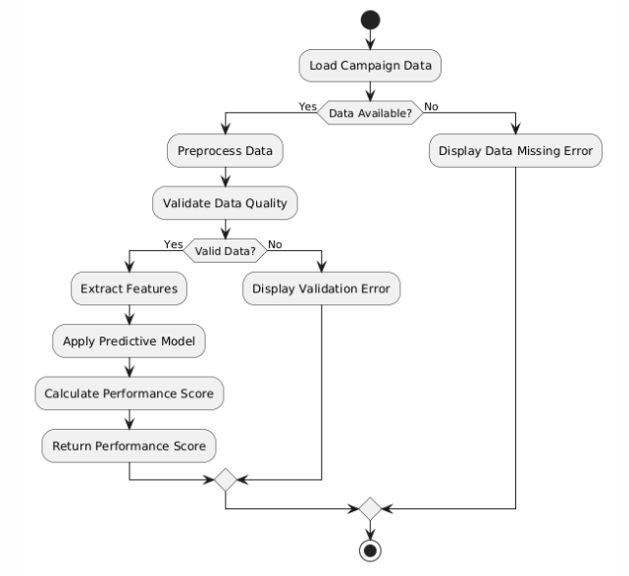

Algorithm 2: Logic-Constrained Reasoning
Purpose
The Logic-Constrained Reasoning algorithm applies symbolic business rules to candidate marketing actions. The objective is to ensure recommendations remain aligned with organisational constraints and business objectives.
Detailed Description
Candidate actions generated from predictive attribution are evaluated against a set of weighted business rules. Each rule contributes a score based on its relevance and importance. Actions violating critical rules receive penalties. The final ranking combines predictive performance and symbolic rule scores, producing an explainable recommendation.
Pseudocode
Algorithm LogicConstrainedReasoning
Input: CandidateActions, BusinessRules
Output: RecommendedAction
BEGIN
Load BusinessRules
FOR each Action
Score = 0
FOR each Rule
Evaluate Rule
IF RuleSatisfied THEN
Score += RuleWeight
ELSE
Score -= Penalty
END IF
END FOR
Store FinalScore
END FOR
Rank Actions
Return Best Action
END
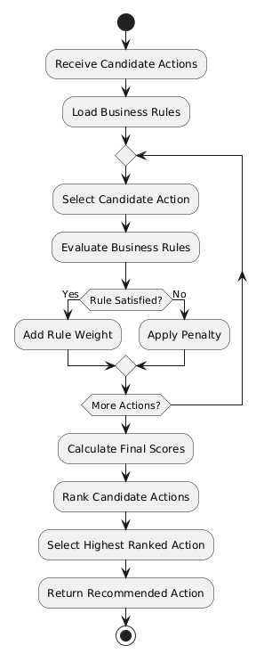

Algorithm 3: Trust Calibration
Purpose
The Trust Calibration algorithm estimates recommendation confidence and adjusts system output to encourage appropriate user reliance on AI-generated recommendations.
Detailed Description
The algorithm receives recommendation scores from the reasoning module and estimates confidence using historical performance patterns. Calibration techniques are applied to reduce overconfidence or underconfidence. The resulting trust score is presented to users alongside the recommendation.
Pseudocode
Algorithm TrustCalibration
Input: RecommendationScore
Output: TrustScore
BEGIN
Receive RecommendationScore
Estimate Confidence
Apply Calibration
Generate TrustScore
Return TrustScore
END
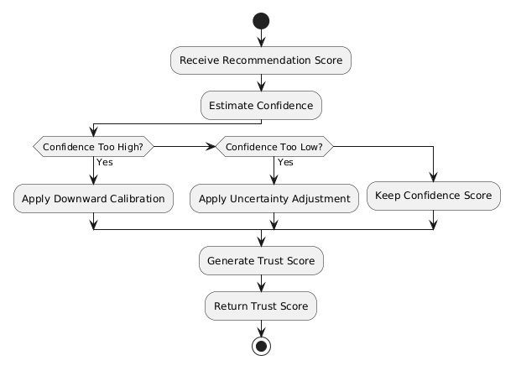

Algorithm 4: Explanation Generation
Purpose
The Explanation Generation algorithm produces human-readable explanations that justify recommendations and improve transparency.
Detailed Description
The algorithm analyses the selected recommendation together with the underlying predictive and symbolic reasoning results. Key decision drivers are identified and translated into understandable business language. The explanation includes rationale, expected implications, recommended actions, and caveats.
Pseudocode
Algorithm ExplanationGeneration
Input: Recommendation
Output: Explanation
BEGIN
Receive Recommendation
Identify Key Drivers
Generate Implications
Generate Actions
Generate Caveats
Construct Explanation
Return Explanation
END
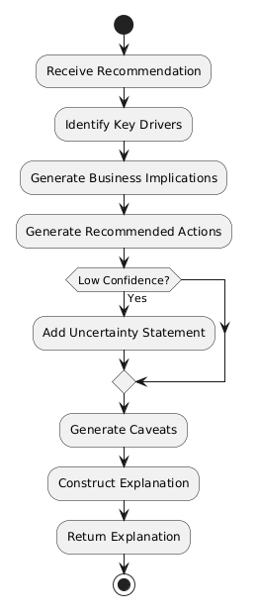

User Interface Design
1. Login
2. Dashboard
3. Campaign Management
4. Add/Edit Campaign
5. Campaign Analysis
6. Generate Recommendation
7. Recommendation Details
8. Recommendation History
9. Evaluation
10. Profile
11. Rule Management (Admin)

Chapter Summary and Evaluation
This chapter presented the detailed system design of the proposed Intent-Aware Logic-Constrained Neuro-Symbolic Decision Support System with Trust Calibration. The overall architecture, workflow, UML models, database design, algorithms, and user interface design collectively provide a blueprint for system implementation.
The modular design ensures consistency with the research methodology and supports future extensibility. The following chapter presents the implementation and testing of the proposed system.

Chapter 5

Implementation and Testing

Implementation and Testing
A short introduction that describes what will be included in this chapter.
IMPORTANT NOTE TO STUDENTS: Include details about:

- Implementation
A detailed description of how you actually carried out the implementation (e.g., coding, etc.) of your system/prototype.
- Include code snippets and descriptions to show how the requirements of the application/prototype have been met –
  - For Smart Campus projects, code snippets of the MQTT protocol for both client side and server side has to be included with explanation.
- Include descriptions of important settings - Setting for server, network protocol, IP, database, security
- Note: this should not be a chronological account of the work you carried out.

- Testing
All test cases that have been carried out must be provided - To tabulate the test cases in tables

Note: Students may also opt to split Implementation and Testing into 2 separate chapters.

Sub-section 1 Heading
Sub-sections should be used to divide the chapter into logical parts.

Sub-subsection Heading
Sub-section numbering should be limited to a maximum of 3 levels (e.g. 5.3.1) in order to avoid confusion.

Sub-section 2 Heading

Sub-section 1 Heading
Sub-sections should be used to divide the chapter into logical parts.

Sub-subsection Heading
Sub-section numbering should be limited to a maximum of 3 levels (e.g. 5.3.1) in order to avoid confusion.

Sub-section 1 Heading
Sub-sections should be used to divide the chapter into logical parts.

Sub-subsection Heading
Sub-section numbering should be limited to a maximum of 3 levels (e.g. 5.3.1) in order to avoid confusion.

Chapter Summary and Evaluation
At the end of each chapter, evaluate the contents stated or discussed in the relevant sub-sections.

Chapter 6 (if applicable)

System Deployment

System Deployment
This chapter would be applicable for students who have embarked on a real-life industrial project. Students in this case would need to describe how the deployment has been carried out. Some of implementation tasks which need to be described include: training, file conversion or creation, and changeovers.

System Backup and Risk Management
Describe the procedures to backup the existing system for changeover purpose. Discuss the potential risk(s) for the changeovers and the solution.

On-site Setup
Describe the preparations to be done prior to the setup of the new system on client’s site. Discuss the procedures to setup the new system, schedule, etc.

Training Procedure
Describe the procedures on the training procedures, contents, schedule, etc.

Follow-up
Describe the plan or procedures to follow up with the client (company) to verify the system reliability.

Chapter Summary and Evaluation
At the end of each chapter, evaluate the contents stated or discussed in the relevant sub-sections. For example,
- Problems faced. Describe the various problems faced by students in the course of doing the project.
- Solutions. What have been done to solve the problems?
- What tools and techniques have been used and reasons for using them.

Chapter 7

Discussions and Conclusion

Discussions and Conclusion
Each student is required to make an evaluation of the project he/she has embarked on. The project evaluation may include the following sections.
IMPORTANT NOTE TO STUDENTS: In this chapter, for problems related to code, hardware, internet connection, etc (where applicable):
  - List the technical problems faced and state how they were resolved
  - List the unsolved technical problems for future enhancement
  - List the achieved objectives/modules
  - List the incomplete parts for future enhancement - this is regardless the parts listed in the pre-determined scope. Suggestions for future improvement

Summary
Summarize the project including the problem and proposed solutions, justification of the choice of tools, techniques and methodologies used in this project.

Achievements
Students are required to evaluate the project’s achievement against project objectives, completion of the project, students’ view of the strengths and weaknesses of the work done.

Contributions
Discuss the creativity, innovativeness, contribution of the proposed system. Explain why the proposed system is necessary. Describe the marketability of the system.

Limitations and Future Improvements
Identify the limitations of the research or project. Provide suggestions for improvement or further development of the system or research in the future.

Issues and Solutions
Students are required to describe the various problems faced by students during the project development and explain what has been done to solve the problems. The valuable experiences gained or lessons learnt through the project as a whole. The issues may include technical issues, project management issues, team dynamics problems, and other difficulties encountered and lessons learnt. How the issues are solved or can be solved to ensure the project can be completed on time or to be improved in the future.

References
Anderl, E., Becker, I., von Wangenheim, F., & Schumann, J. H. (2016). Mapping the customer journey: Lessons learned from graph-based online attribution modeling. International Journal of Research in Marketing, 33(3), 457–474. https://doi.org/10.1016/j.ijresmar.2016.03.001
Barredo Arrieta, A., Díaz-Rodríguez, N., Del Ser, J., Bennetot, A., Tabik, S., Barbado, A., García, S., Gil-López, S., Molina, D., Benjamins, R., Chatila, R., & Herrera, F. (2020). Explainable artificial intelligence (XAI): Concepts, taxonomies, opportunities and challenges toward responsible AI. Information Fusion, 58, 82–115. https://doi.org/10.1016/j.inffus.2019.12.012
Berman, R. (2018). Beyond the last touch: Attribution in online advertising. Marketing Science, 37(5), 771–792. https://doi.org/10.1287/mksc.2018.1104
Dellermann, D., Ebel, P., Söllner, M., & Leimeister, J. M. (2019). Hybrid intelligence. Business & Information Systems Engineering, 61(5), 637–643. https://doi.org/10.1007/s12599-019-00595-2
Green, B., & Chen, Y. (2019). Disparate interactions: An algorithm-in-the-loop analysis of fairness in risk assessments. In Proceedings of the Conference on Fairness, Accountability, and Transparency (pp. 90–99). ACM. https://doi.org/10.1145/3287560.3287563
Guo, C., Pleiss, G., Sun, Y., & Weinberger, K. Q. (2017). On calibration of modern neural networks. In D. Precup & Y. W. Teh (Eds.), Proceedings of the 34th International Conference on Machine Learning (Vol. 70, pp. 1321–1330). PMLR.
Kaur, H., Nori, H., Jenkins, S., Caruana, R., Wallach, H., & Wortman Vaughan, J. (2020). Interpreting interpretability: Understanding data scientists' use of interpretability tools for machine learning. In Proceedings of the 2020 CHI Conference on Human Factors in Computing Systems (pp. 1–14). https://doi.org/10.1145/3313831.3376219
Lee, J. D., & See, K. A. (2004). Trust in automation: Designing for appropriate reliance. Human Factors, 46(1), 50–80. https://doi.org/10.1518/hfes.46.1.50_30392
Lepenioti, K., Bousdekis, A., Apostolou, D., & Mentzas, G. (2020). Prescriptive analytics: Literature review and research challenges. International Journal of Information Management, 50, 57–70. https://doi.org/10.1016/j.ijinfomgt.2019.04.003
Li, H., & Kannan, P. K. (2014). Attributing conversions in a multichannel online marketing environment: An empirical model and a field experiment. Journal of Marketing Research, 51(1), 40–56. https://doi.org/10.1509/jmr.13.0050
Marra, G., Dumančić, S., Manhaeve, R., & De Raedt, L. (2024). From statistical relational to neurosymbolic artificial intelligence: A survey. Artificial Intelligence, 328, 104062. https://doi.org/10.1016/j.artint.2023.104062
Okamura, K., & Yamada, S. (2020). Adaptive trust calibration for human-AI collaboration. PLOS ONE, 15(2), e0229132. https://doi.org/10.1371/journal.pone.0229132
Ribeiro, M. T., Singh, S., & Guestrin, C. (2016). "Why should I trust you?": Explaining the predictions of any classifier. In Proceedings of the 22nd ACM SIGKDD International Conference on Knowledge Discovery and Data Mining (pp. 1135–1144). https://doi.org/10.1145/2939672.2939778
Schemmer, M., Kühl, N., Benz, C., Bartos, A., & Satzger, G. (2023). Appropriate reliance on AI advice: Conceptualization and the effect of explanations. In Proceedings of the 28th International Conference on Intelligent User Interfaces (pp. 410–422). ACM. https://doi.org/10.1145/3581641.3584066
Vasconcelos, H., Jahanbakhsh, F., Krishna, S., et al. (2023). Explanations can reduce overreliance on AI systems during decision-making. In Proceedings of the AAAI/ACM Conference on AI, Ethics, and Society. https://doi.org/10.1145/3600211.3604680
Wedel, M., & Kannan, P. K. (2016). Marketing analytics for data-rich environments. Journal of Marketing, 80(6), 97–121. https://doi.org/10.1509/jm.15.0413
Bhuyan, B. P., Ramdane-Cherif, A., Tomar, R., & Singh, T. P. (2024). Neuro-symbolic artificial intelligence: A survey. Neural Computing and Applications, 36(21). https://doi.org/10.1007/s00521-024-09960-z
Himabindu, M., V, R., Gupta, M., Rana, A., Chandra, P. K., & Abdulaali, H. S. (2023). Neuro-symbolic AI: Integrating symbolic reasoning with deep learning. In 2023 10th IEEE Uttar Pradesh Section International Conference on Electrical, Electronics and Computer Engineering (UPCON). IEEE. https://doi.org/10.1109/UPCON59197.2023.10434380
Shakarian, P., Baral, C., Simari, G. I., Xi, B., & Pokala, L. (2023). Neuro symbolic reasoning and learning. Springer. https://doi.org/10.1007/978-3-031-39179-8

Appendices
In order to enhance better understanding of the project, students should as far as possible include all directly relevant materials, figures or diagrams in the main body rather than in the Appendix. The appendix is reserved only for items which may not directly be relevant or essential to enhance a reader’s understanding of the project, or which may interrupt the smooth reading of the project document (for example being too voluminous).
Appendices should only include supportive materials directly referred to in the writing and should be kept to a minimum, e.g. selected pages of an annual report, not the entire document. Examples of items included in Appendices are:
- Company’s report and documentation, such as sample invoice, purchase order form, etc.
- Project meeting documentation e.g. minutes of meetings, tracking documents, memos etc.
- Questionnaires and results, interview questions and results, pilot test and results, observation sheet and results, experiment test plan and results, etc.
- Analysis/design diagrams (only those not incorporated in the main body of the report).

If there is more than one appendix, they should be identified as A, B, etc (e.g. Appendix A). Formulae and equations in appendices should be given separate numbering: Eq. (A.1), Eq. (A.2), etc.; in a subsequent appendix, Eq. (B.1) and so on. Similarly for tables and figures: Table A.1; Fig. A.1, etc.

IMPORTANT NOTE TO STUDENTS

APPENDIX n User Guide
- List the username and password of multiple roles (if applicable)
- Provide clear screen shots of each page, explain the functions of each button

As a rough guide, the user guide should include the following sections:

System Document
In this section, students should provide the following pieces of information:
- System (hardware and software requirements). Students should describe the minimum hardware and software requirements to install the software application which has been developed by the students, for example, DBMS, OS, program development tools etc.
- Installation. Under this section, students should create an ‘installation’ CD and provide a brief step-by-step guide on how a new user can install the software on a computer system. Students should indicate any special setup information, such as the specific location of placing the database files, the SQL statements to add tables, etc. Software source code should also be included in this CD. Students are not required to print out the software code.
Operation Document
Under this section, students are required to provide a brief step-by-step guide on how to use the installed software. The guides should teach the user how to run the software and use its major functions and features. For example, steps show guide the users on how to run the system, e.g. to use an executable file or to use the IDE. The login information such as username and password for each of the different users (or roles) must be provided. Some screen interfaces would be useful.

APPENDIX n+1 Developer Guide*
*To be included for Smart Campus Projects and Real-Life Projects. This section should include the following:
- List the necessary software, installer, API, library that must be installed
- List the authentication details, such as username and password for all security

Other Appendices:
  - Supporting documents
  - Non-disclosure agreement (if applicable)
  - Other detailed documentation, such as important references, interview results, survey results, etc.

This page is intentionally left blank to indicate the back cover. Ensure that the back cover is black in color.

